

Introduction to Zindagi Mehfooz Program

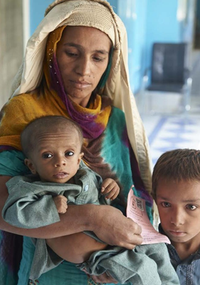

Despite the considerable progress, Pakistan continues to lag behind the rest of the countries when it comes to reducing the burden of child mortality. Pakistan’s child mortality rate currently stands at 74 deaths per 1,000 live births, whereas child mortality rate of Sindh is 77 deaths per 1000 live births. Immunization coverage across Sindh remains suboptimal as only 49% of the eligible children have successfully completed their entire course of routine immunizations. In order to address the aforementioned issues, Interactive Research and Development (IRD), in collaboration with the Health Department of Sindh, introduced the Zindagi Mehfooz (ZM) program which leverages low-cost technology to enable vaccinators to enroll and track every child and pregnant woman who presents for immunization at an Expanded Program on Immunization (EPI) center or outreach site. This program was originally piloted in 2012 in Shikarpur and the baseline survey conducted revealed a considerable increase in the number of children who had successfully completed their entire course of vaccination, from 18% to 54%. In light of this three-fold increase in the immunization coverage, this program was scaled-up in 2017 across the entire Sindh province in Pakistan. The primary objective was to strengthen the existing network of the EPI in order to alleviate the burden of child mortality throughout the province. This Android-based Electronic Immunization Registry generates real-time actionable data to facilitate the program in increasing immunization coverage, equity, and timeliness. ZM features an electronic decision support system to guide vaccinators for routine and catch-up immunizations, Quick Response (QR) Codes as unique child identifiers, and SMS reminders for parents for upcoming immunization visits. The application is supported through a web-based dashboard allowing preparation of performance-based immunization reports, defaulters reports, population-based coverage reports, vaccinators tracking and attendance, vaccinators micro-planning and surveillance forms, as well as vaccine stock maintenance.

Dashboard - LOGIN Screen

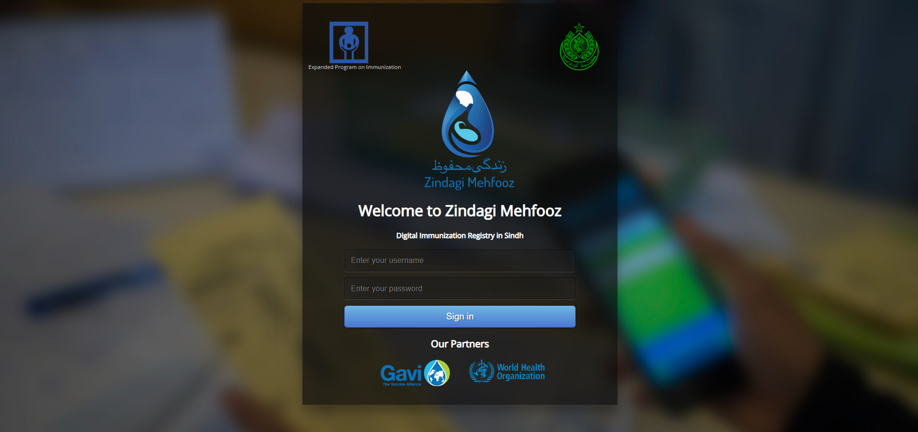

> Sign in is done by typing in the given credentials by the program team of SEIR.
> URL for accessing the dashboard is https://zm-epi.org/login.htm
Enter your username
Enter your password
> Due to the data protection measures, the credentials are pre-generated by System Administrator/ Maintainer for each user at different level.

(Note: User IDs and Passwords are confidential, hence do not share it with anyone).

1. MainPage - (Statistics & Immunization Monitoring Chart)

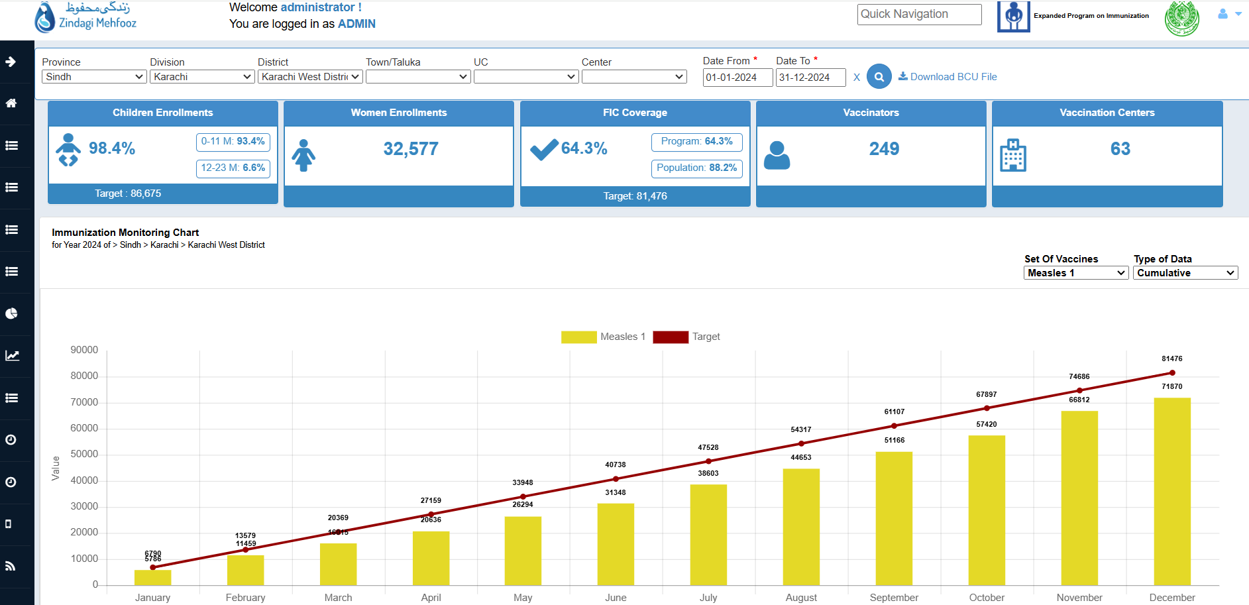

> The Quick Navigation bar is pinned at the top and will be visible all the time. Use it to quickly toggle through different tabs.

> Data can be filtered through the given location and date filters. Province>Division>District>Town>UC>Center

Key Indicators of SEIR:
- Child enrollment with EPI Targets.
- Women enrollment.
- Fully Immunized Child coverage.
- Number of Vaccination Centers.
- Number of Vaccinators.
> Location based data appropriately is also maintained. User bound with particular can only view data of sub-locations under his location.

> The Immunization Monitoring Chart provide you oversights with cumulative usage of each antigens along with the targets. Following chart can be used to view antigens usage/coverage with respect to each month.
(Note: You can view this data in Table, or Download in PDF/Excel form by clicking these options)

1.1. MainPage - (Defaulters Graph and Gender Graph)

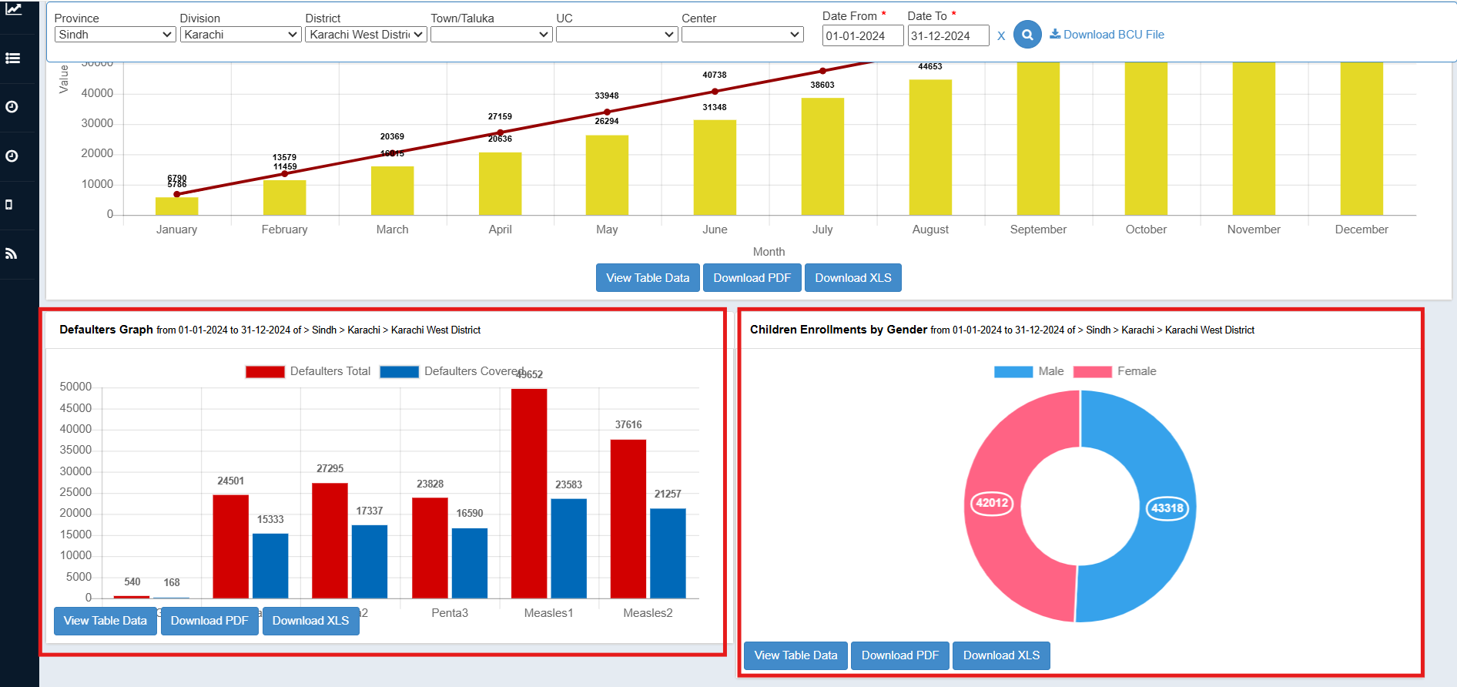

> The Defaulters Graph shows the total number of defaulters categorized by vaccines and the number of defaulters covered by vaccine.
> The Children Enrollments by Gender shows the Total number Children enrolled, categorized by their genders(i.e. Male/Female).

(Note: You can view this data in Table, or Download in PDF/Excel form by clicking these options)

1.2. Navigation Bar
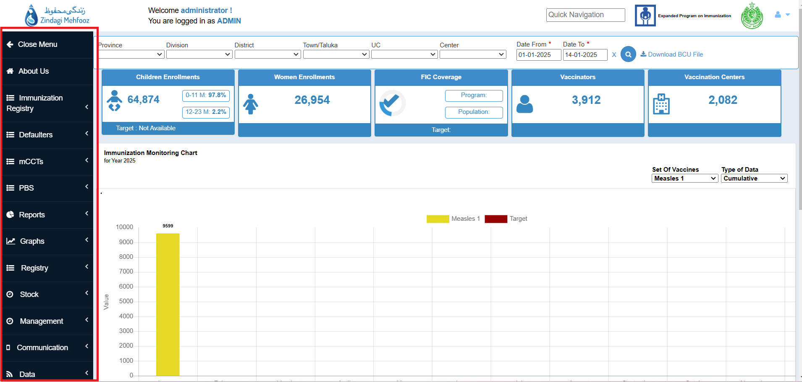

> Navigation Bar leads you to different reports and options of Dashboard.

List Of Reports/Options:
- Immunization Registry (Daily and Permanent Registers).
- Defaulters (Child and Woman)
- mCCTs Reports
- PBS Reports
- Reports (Compliance and Coverage, Performance, Registry, ATP).
- Graphs (Attendance and Compliance)
- Stock
- Management (Attendance, Users and Leave)
- Communication
- Data

2. Immunization Registry
Immunization Registry represent immunization details of the both Child and Woman. This section includes Daily and Permanent registers for Child and Woman also campaigns and Mobile(Van) Immunizations details.

2.1. Daily Immunization Register

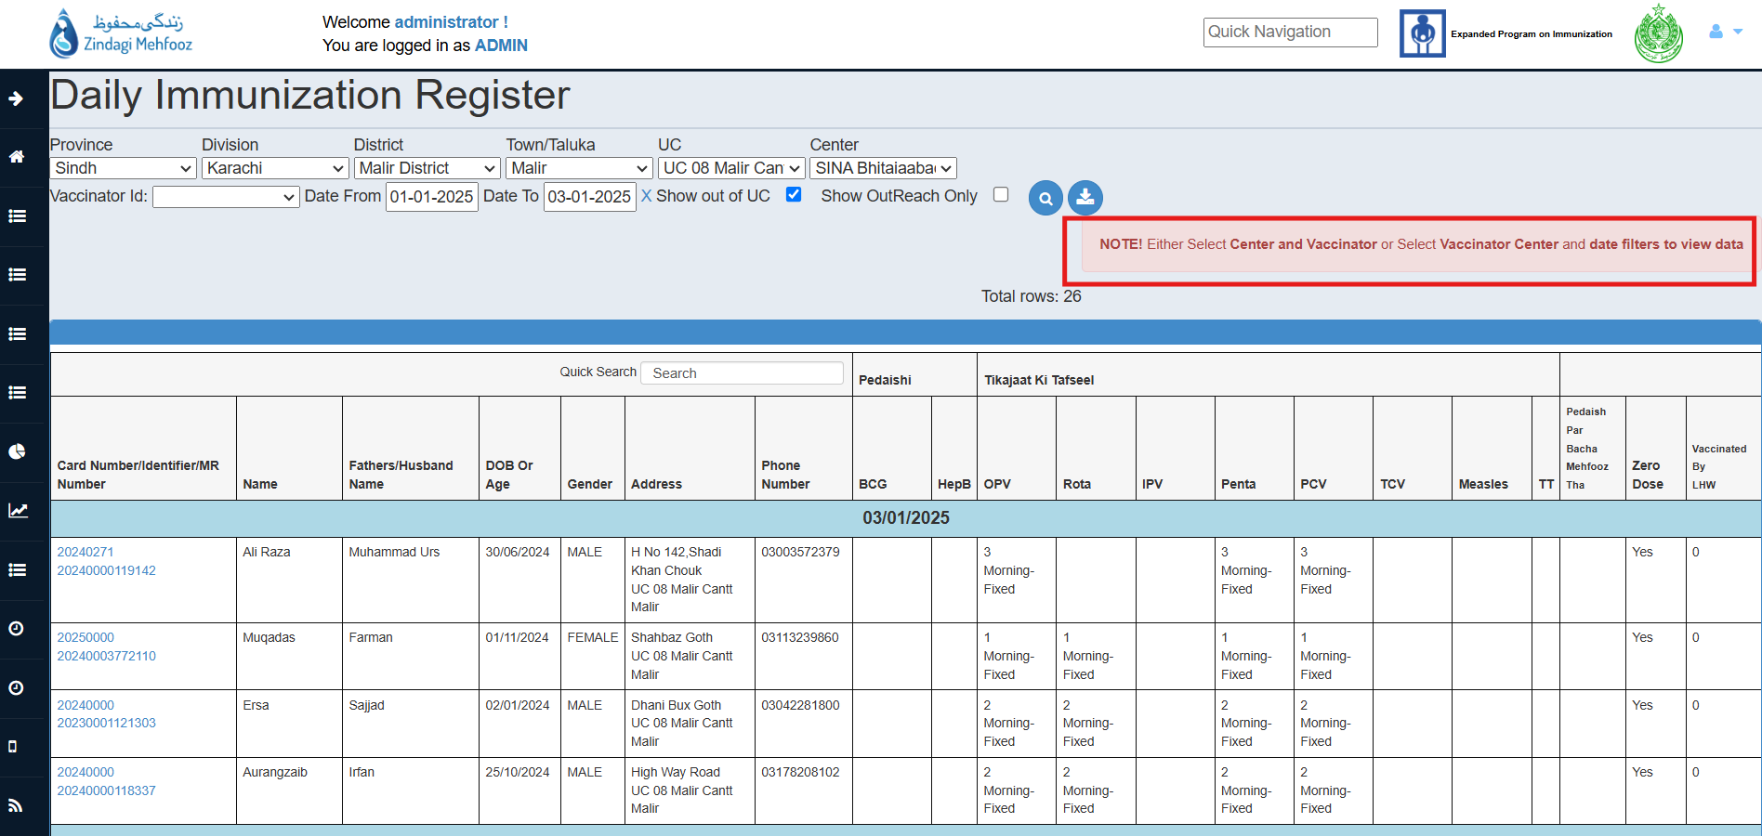

> Daily Register gives the information of vaccination events and antigens administered to children by center and by vaccinator between particular date ranges.
> It also highlights if the child vaccinated is Inside/Outside UC and vaccination session type (Fixed/Outreach).
> Daily Register is a live report where the data can be seen immediately after adding the information from ZM Application. The same report is downloadable on Vaccinator’s ZM Application.
> Daily register covers both i.e. Women and Children.

2.2. Permanent Immunization Register For Children

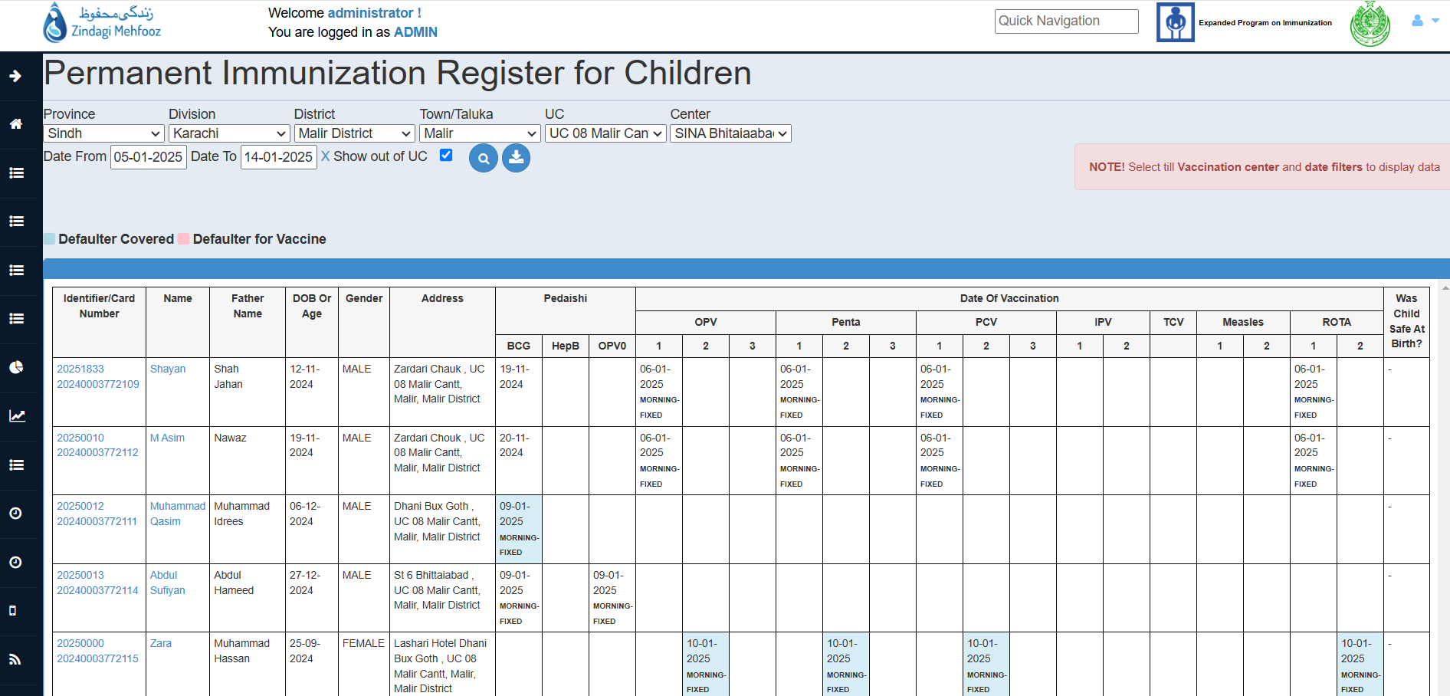

> Permanent Register gives complete child information along with vaccination record in respect with the enrollment date.
> Each Antigen with its administration date is reflected in the permanent register
> Permanent register highlights all children of the same UC. The child highlighted as blue in Antigen Box is defaulter who is covered.
> Permanent register highlighted as pink in Antigen Box if child defaulted.

2.3. Permanent Immunization Register For Women

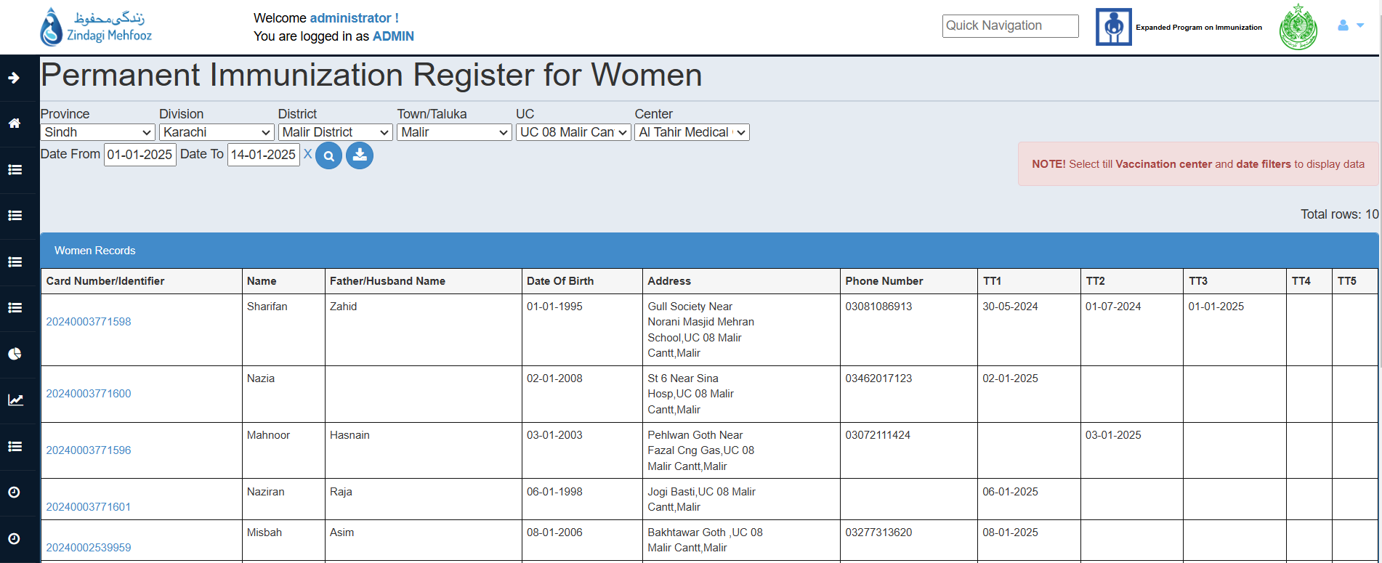

> Permanent Register gives complete women information along with vaccination record in respect with the enrollment date.
> Each Antigen with its administration date is reflected in the permanent register.

2.4. Campaign
Campaigns section is used to Add/View Campaigns, and to view campaign data as per activities performed in the campaign.

2.4.1. View Campaigns

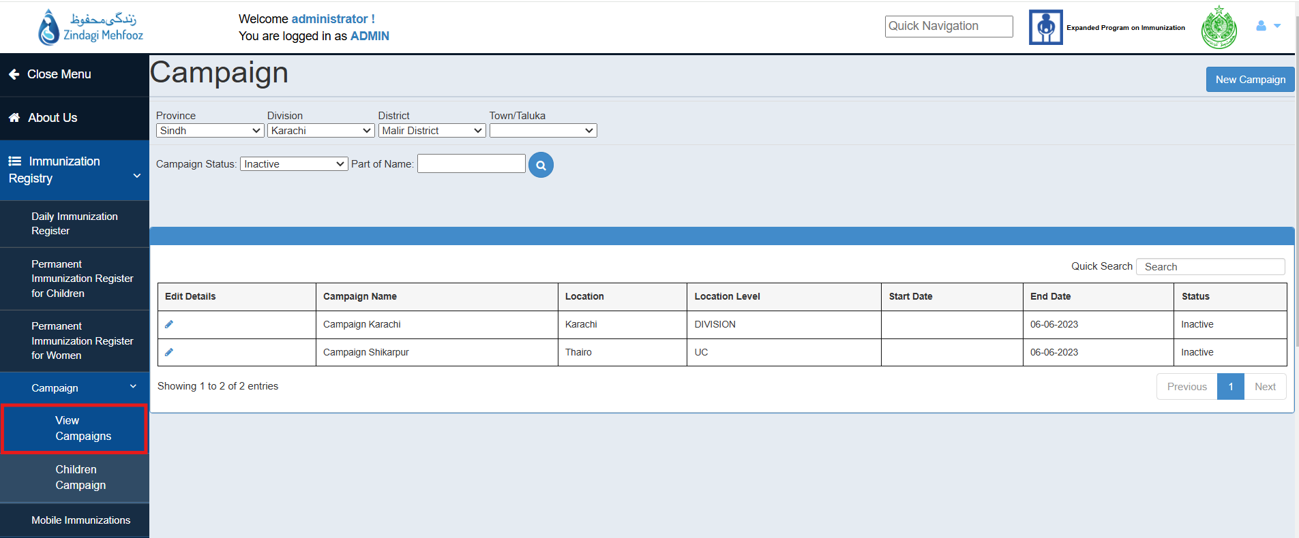

> New Campaigns can be created from New Campaign button.
> Campaigns are auto-voided once the campaign end date is passed.

Guide To Add New Campaign:

> Campaigns can be created from Add Campaign option.
> Each Campaign has a start and end date with a fixed vaccine to be selected from the list of campaign vaccines.
> Campaigns can be created on all location levels (Province – UC). Active campaign will only be reflected on vaccinator’s ZM Application if it is available in his District / Tehsil / UC.
> Campaigns allow flexible age limit. Age bracket can be added while creating campaign

Note: Campaigns can be created on any location level, and would only be visible to vaccinators under that location hierarchy.

2.4.2. Children Campaign

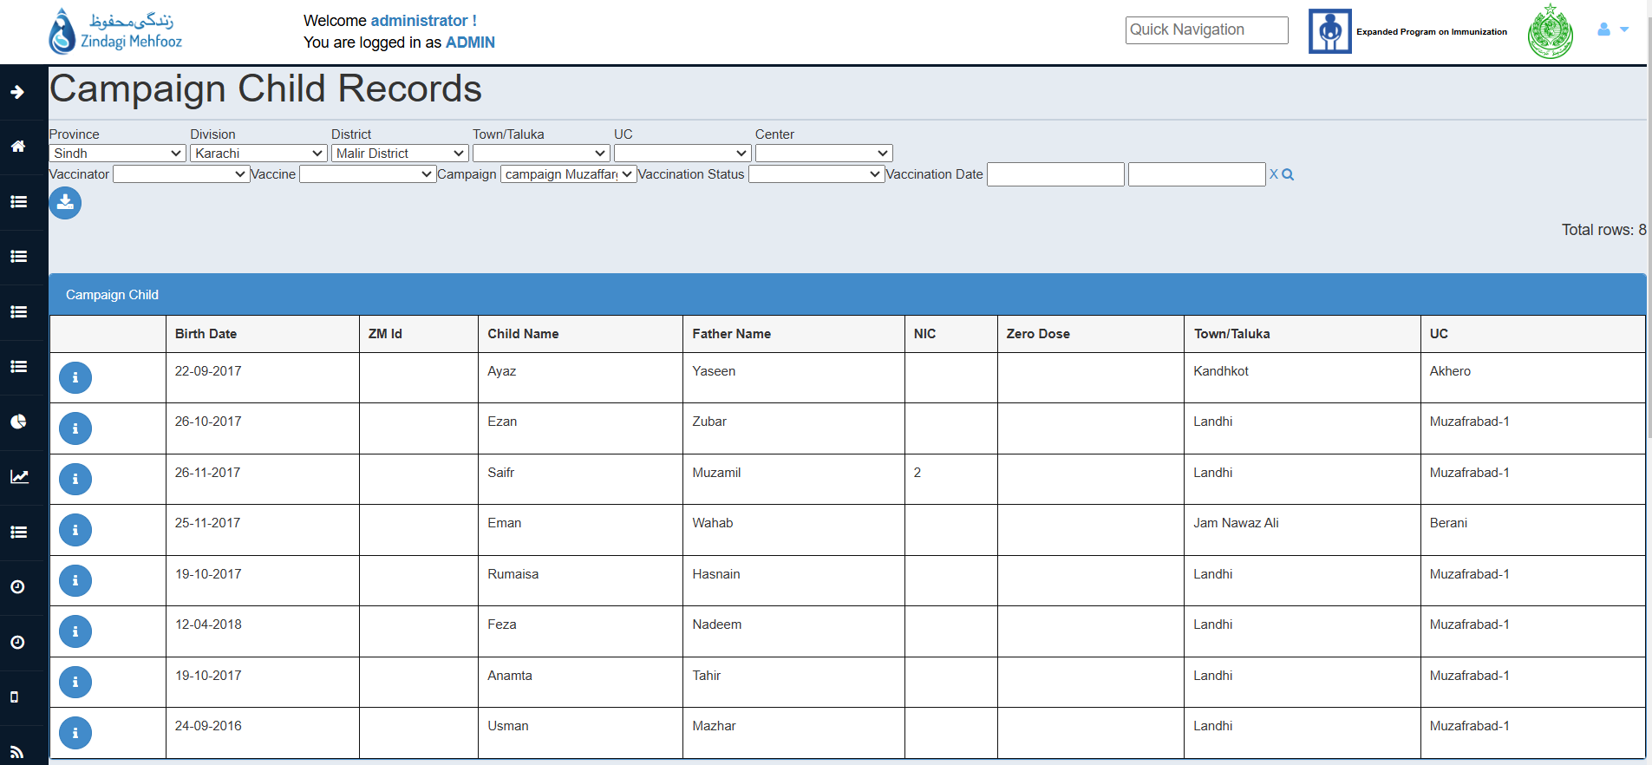

> Children enrolled under campaigns can be viewed from Campaign Child Records.

> The data can be filtered using location, campaigns, vaccinator, vaccines, vaccination dates, and vaccination status (vaccinated/refused).

2.5. Mobile Immunization

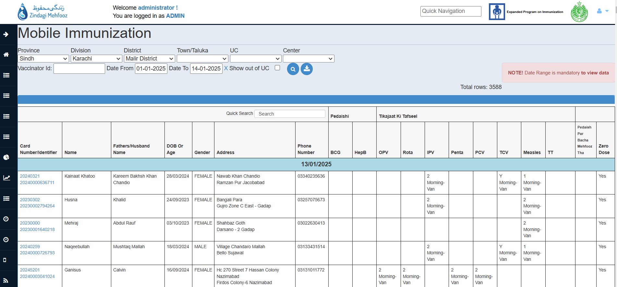

> Mobile Immunization option shows immunization data for children vaccinated via van services.
> Data can be filtered through Location, Vaccinator and Date filters.
> On Checking ‘Out Of UC’ filter, you can see the children which belongs to another UC but immunized on the selected UC.
> Mobile Immunization shows immunization data for children vaccinated via van services of IRD.

3. Defaulters
Following defaulter lists can be seen under the tab of Defaulter Lists and these are downloadable:
- Defaulters list for children
- Defaulters list for women
- Defaulters covered by vaccine
- Defaulters covered by vaccinators

3.1. Defaulters List For Children

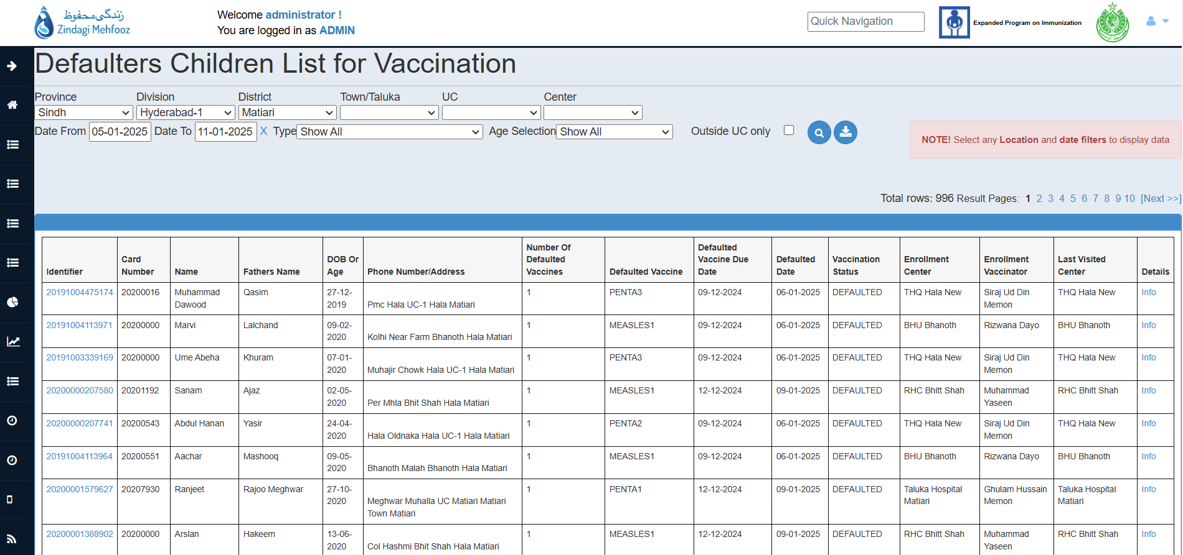

> Defaulter’s list of the given location hierarchy can be seen and downloaded with all the details of child that includes,
- Name & Father Name
- Address & Contact
- Defaulted Vaccine
- Identifier
- Vaccination Statuses
> Further filters can be added to see defaulters: Covered/uncovered.

Note: Further reports on Defaulters covered by antigen and vaccinators can also be fetched from other tabs under Defaulters.

3.2. Defaulters List For Women

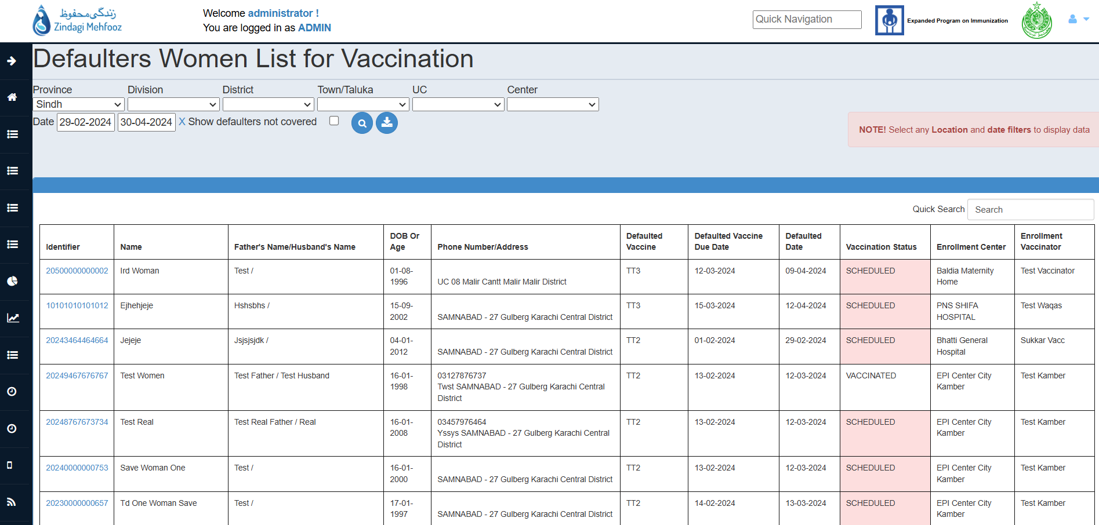

> Defaulter’s list of the given location hierarchy can be seen and downloaded with all the details of women that includes,
- Name & Father/Husband Name
- Address & Contact
- Defaulted Dose of Vaccine
- Identifier
- Vaccination Statuses
> Further filters can be added to see defaulters: Covered/uncovered.

Note: Further reports on Defaulters covered by antigen and vaccinators can also be fetched from other tabs under Defaulters.

3.3. Defaulters Covered By Vaccine

> Defaulters covered by vaccine breaks down the Defaulted children by Vaccine.
> Defaulters list by vaccines can be viewed by entering location hierarchy.
> Defaulters List can be downloaded in CSV format by clicking the download icon.

3.4. Defaulters Covered By Vaccinator

> Following reports reflect the defaulters of Penta and Measles Doses and their coverage against each vaccinator followed by selected Location hierarchy.

> Defaulters list by vaccinator can be viewed by entering location hierarchy.

> Defaulters List by vaccinator can be downloaded in PDF format by clicking the download icon.

4. Reports
Following reports can be seen under the tab of Reports and these reports can be download:
- Performance Indicators.
- Monthly coverage report.
- Monthly compliance report.
- Vaccinator Advance Tour Plan.
- Zero-dose report.
- Child registry.
- Vaccine dropout Report.

4.1. Performance Indicators
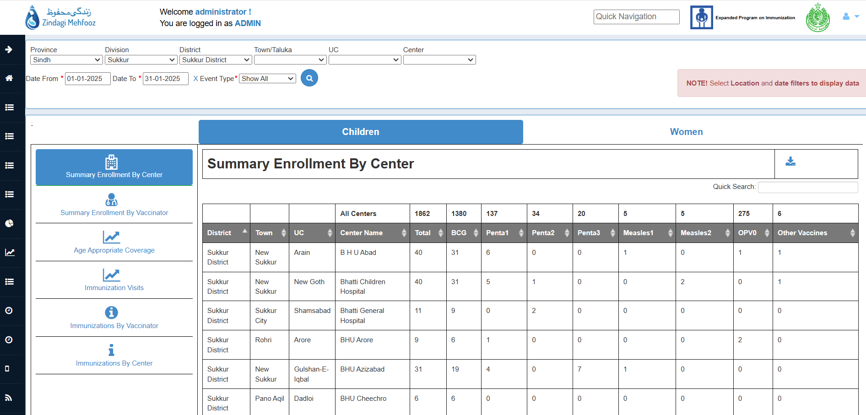
> Performance indicators have different vaccinator and center level reports.
- Summary enrollment by Center.
- Summary enrollment by vaccinator.
- Age-appropriate coverage.
- Immunization visits.
- Immunization by Vaccinator.
- Immunization by Center.

4.1. Performance Indicators (Contd..)

> Summary enrollment option shows the enrollment/coverage either by vaccinators or EPI Centre.

> Age-appropriate coverage compares the vaccinations administered vs vaccinations administered on time.

> Immunization visits option show the enrollment and follow-up visits by vaccinators.

> Immunizations by Vaccinator shows how many vaccines a vaccinator has administered, and their distribution based on the given time period.

> Immunizations by center shows how many vaccines have been administered by a center, and their distribution based on the given time period.

> You can download the list by clicking the download button.
> Data can be filtered through Location and Date filters.
> Data can be viewed for both children and women.

Note: This data is available for both the child and woman creation this for others too where applicable.

4.2. Monthly Coverage Report

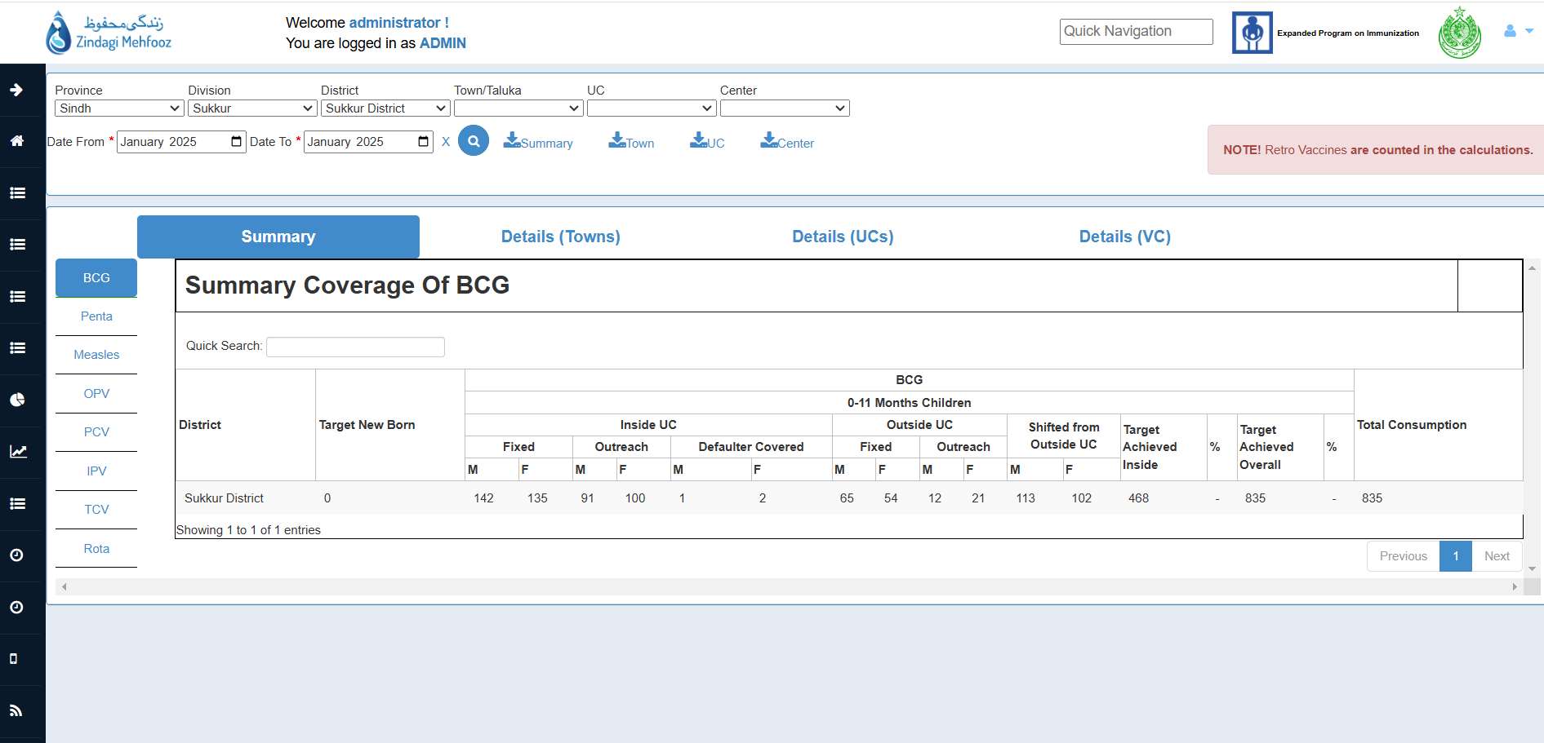

> Antigen wise coverage can be seen and downloaded: UC and Vaccination Center wise.

>The coverage includes:
- Inside UC coverage of vaccine.
- Outside UC coverage of vaccine.
- Shifted from outside UC as well in line with the targets achieved.
>Location filters and date to be added to see the data of the given range and area.

4.3. Monthly Compliance Report

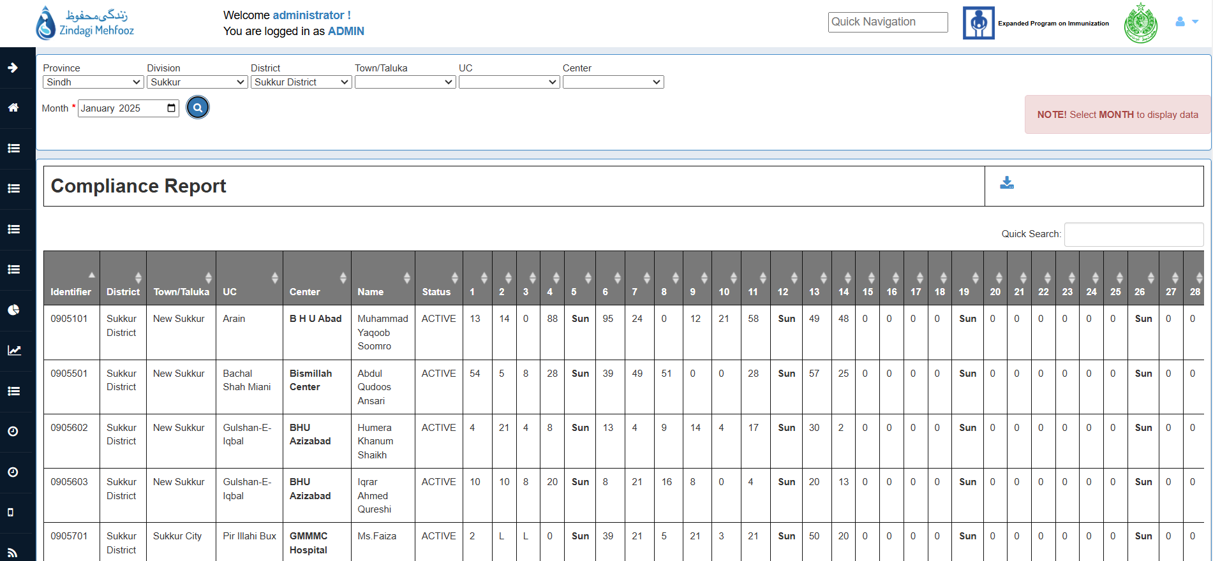

> Compliance report helps in identifying vaccinators who use ZM Application on daily basis.

> Location filters and date to be added to see the data of the given range and area.

> Number of entries (Enrollment & Follow-up) done by vaccinator can be seen and downloaded for the given date range. It also flags public holidays, and Sundays to exclude from working days.

Note: A single antigen / vaccine administered will show 100% compliance for that vaccinator of that day.

4.4. Vaccinator Advance Tour Plan

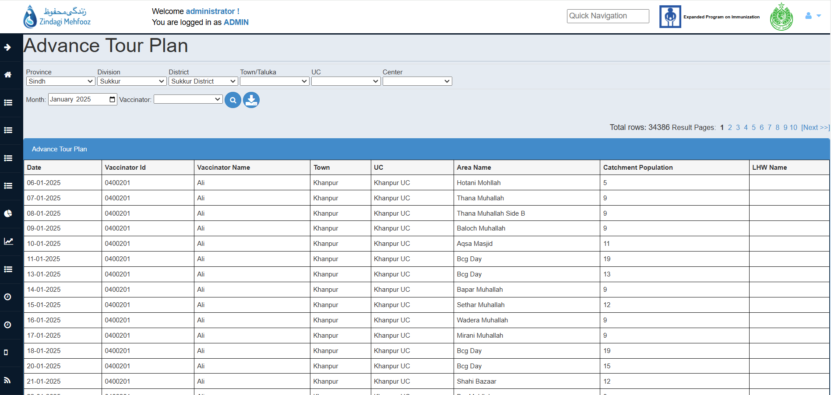

> Vaccinator Advance Tour Plan helps to view the field visits plan against each vaccinator.
> The following report is viewable as per selected Month.

> You can download the CSV list by clicking the download button.
> Data can be filtered through Location and by Vaccinator.

4.5. Child Registry

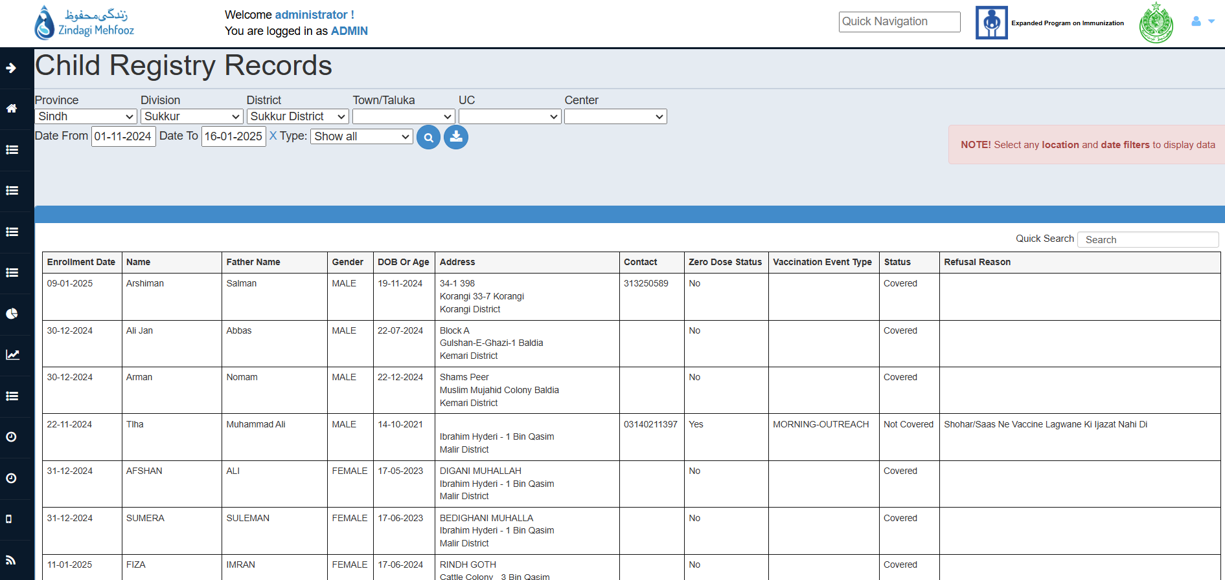

> Child Registry report shows the number of children who are enrolled without a QR and unimmunized from field.

> The report is linked with the routine registry of ZM that when the child goes to EPI center to get vaccine the status changes from not covered to covered.

> Location filters and date to be added to see the data of the given range and area.

4.6. Vaccine Drop-Out Report

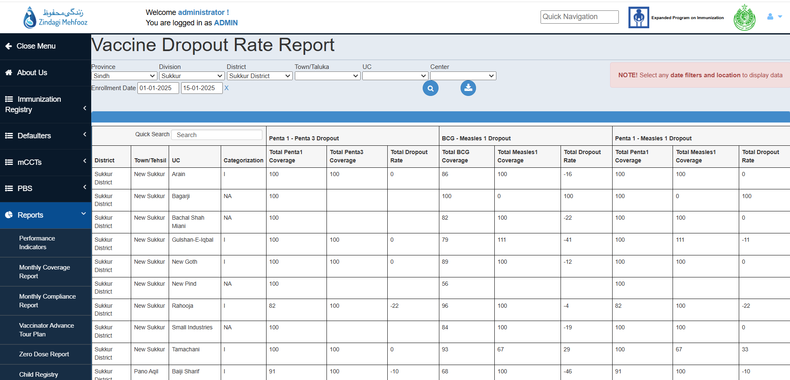

> Vaccine dropout rate report describes the percentage of children who have missed their routine immunization.

> Data can be filtered out on the basis of location and date filters as enrollments.

> UC wise categorization is also available as per P1-P3, BCG-M1, and P1-M1 dropout rates.

5. Graphs
Graphs in ZM represents the visualization of the summary of vaccinator’s attendance as well as the compliance coverage in daily/monthly representation.

5.1. Attendance Graph

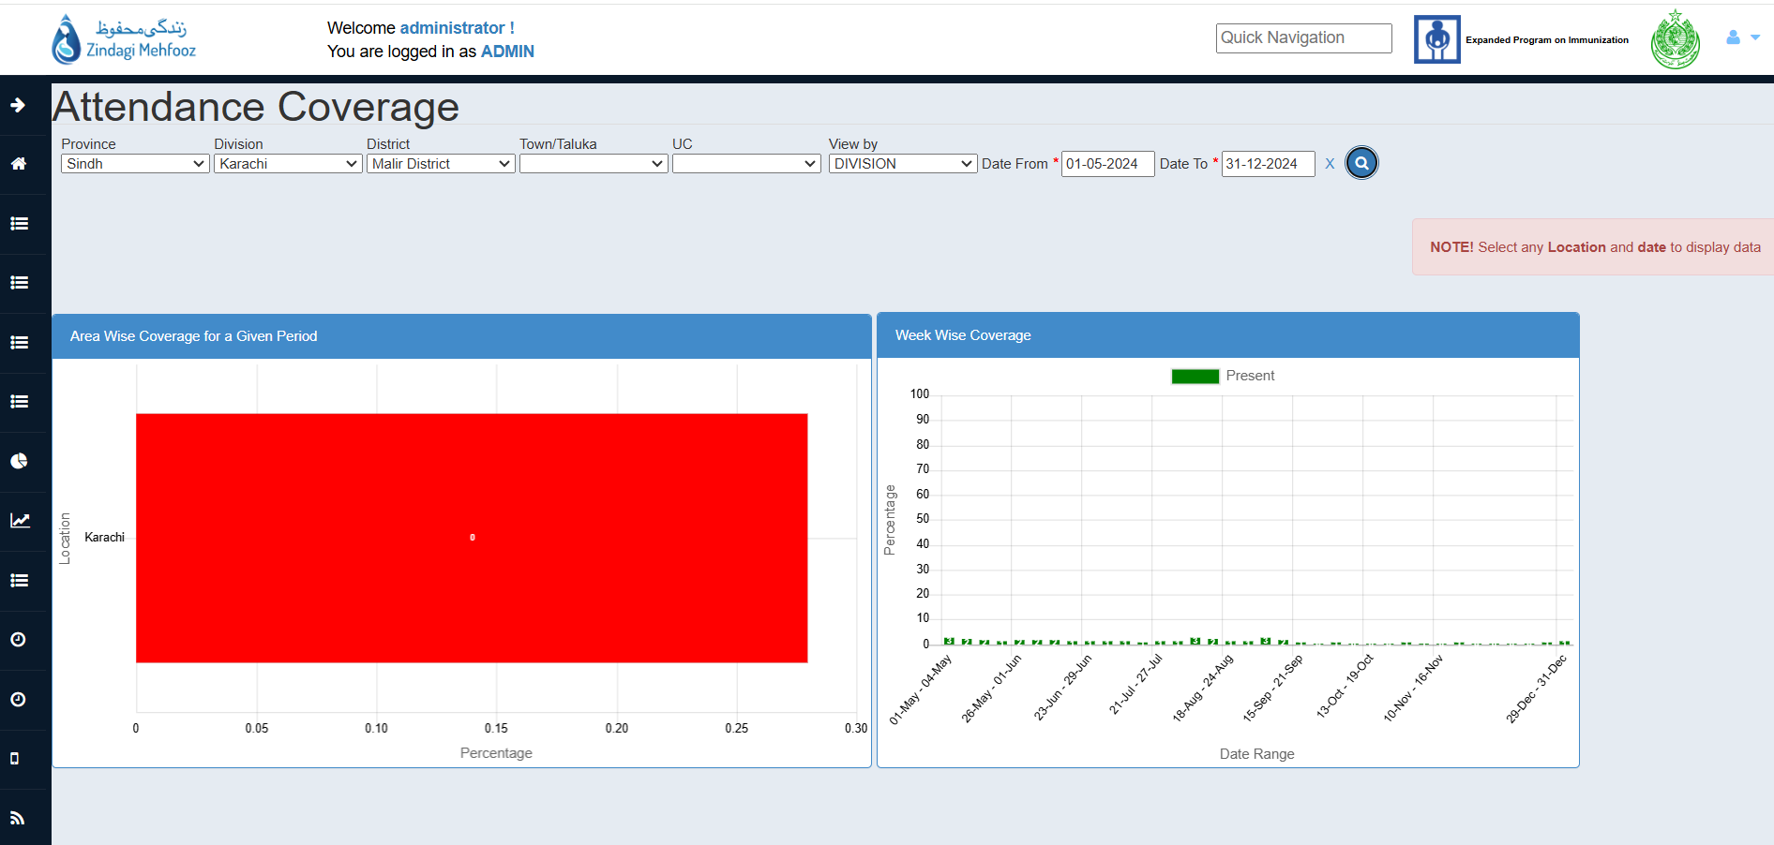

> Attendance of Vaccinators working in Districts can be seen populated in graphs.

> Filter for any location can be added and the data can be viewed in any hierarchy (UC/ Town/ District) through filter “View by”.

> Date filters can be applied to view attendance coverage as per selected level of hierarchy.

5.2. Attendance Summary Graph

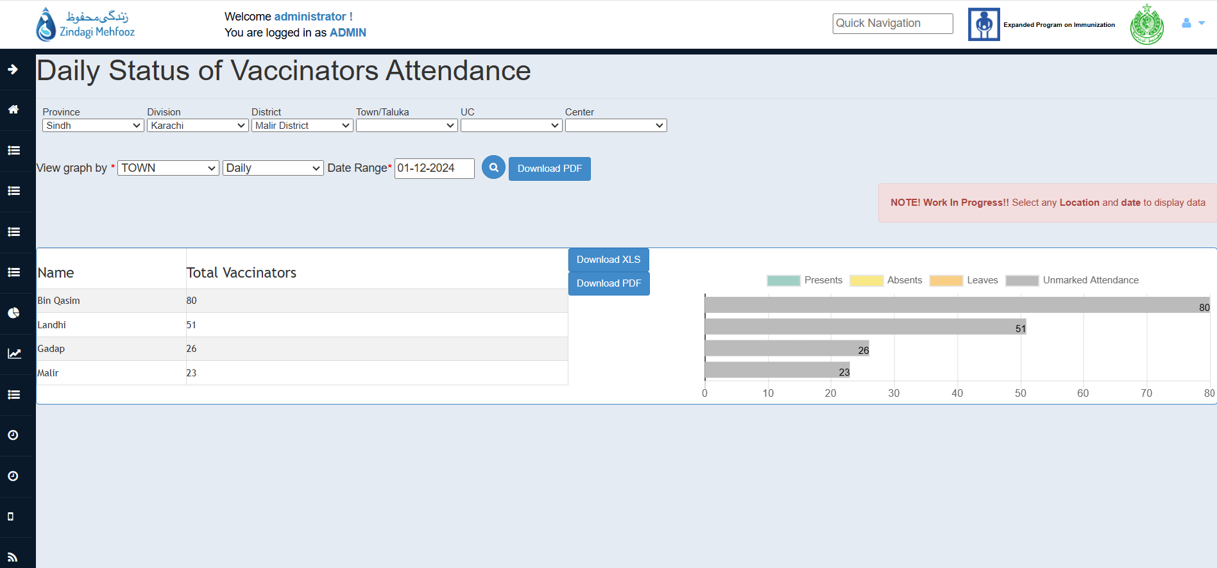

> The Attendance summary graph breaks down attendance into:
- Present
- Absents
- Leaves
- Unmarked Attendance

> Data can be filtered by location and date can be selected as daily or in range.

> Graphs and data can be downloaded in XLS/PDF format by clicking on Download buttons.

5.3. Daily Compliance Graph

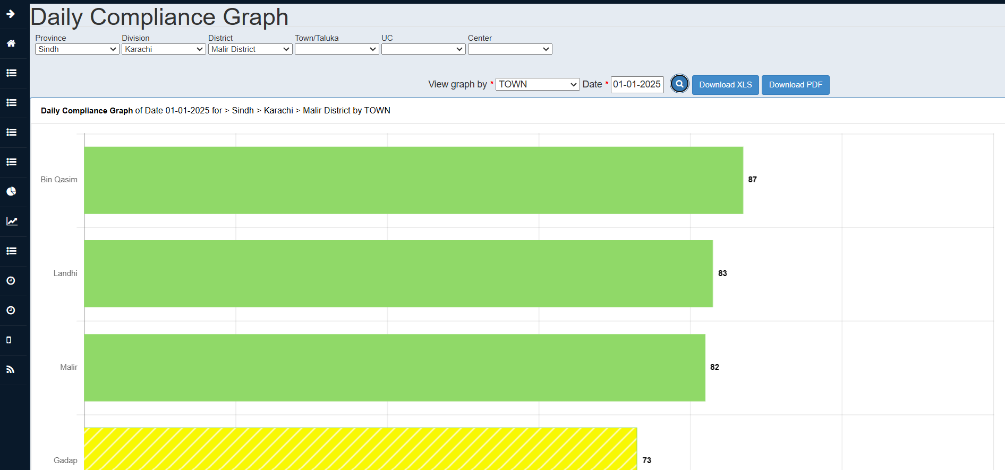

> Daily compliance graph makes it easy to see the number of vaccinators using ZM Application to record entries in the area.

> The Graph can be further shaped into many levels by clicking on ‘View Graph By’ dropdown.

> The Compliance in the Graphs is mentioned in Percentages.

> Graphs and data can be downloaded in XLS/PDF format by clicking on Download buttons.

5.4. Monthly Compliance Graph

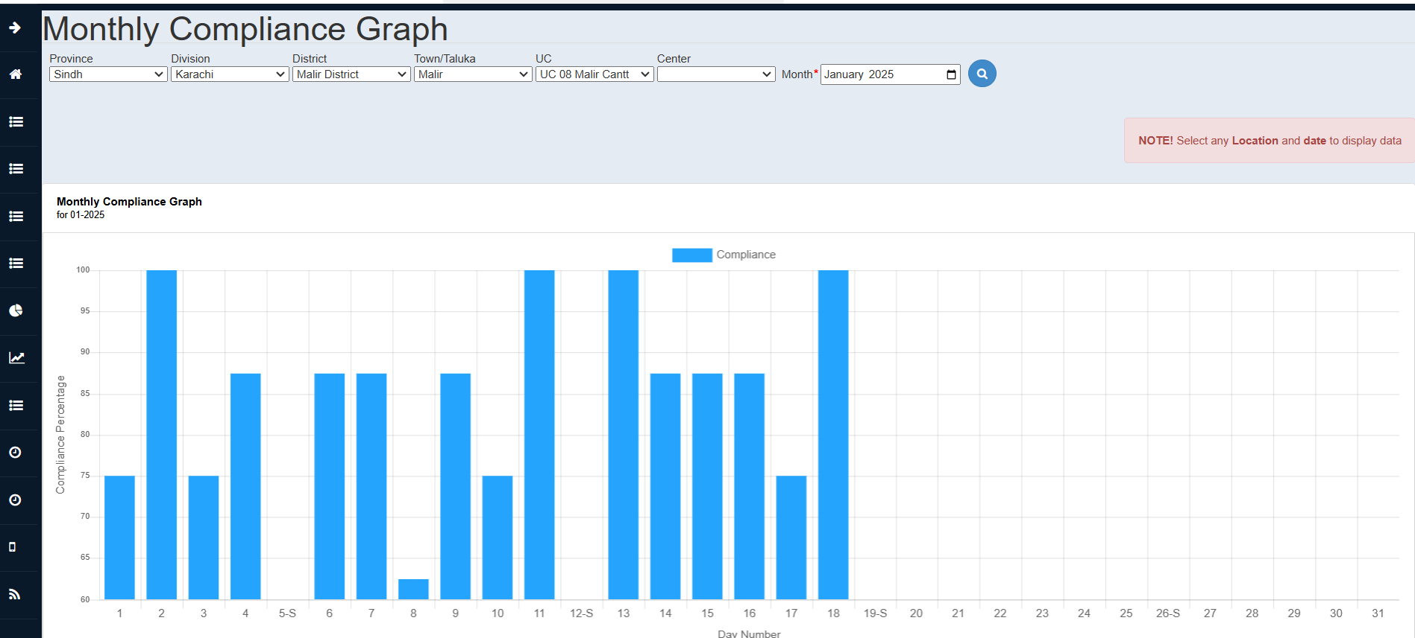

> Monthly compliance graph visualizes the compliance for the whole month.

> The Compliance in the Graphs is mentioned in Percentages.

> Data can be filtered by Location and as per months.

5.5. Compliance Coverage Graph

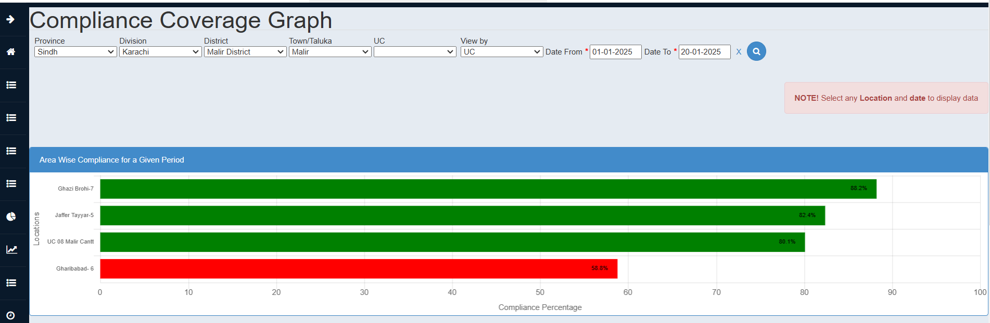

> Area wise compliance shows Percentage of the vaccination targets achieved by Vaccinator.

> Data can be filtered by Location and Date Can be selected as daily or in range.

6. Registry
Registry section provide insights of the Child/Woman related data which includes enrollments of birth registry Children, adverse reports and zero dose children and their statistics.

6.1. Child Dashboard

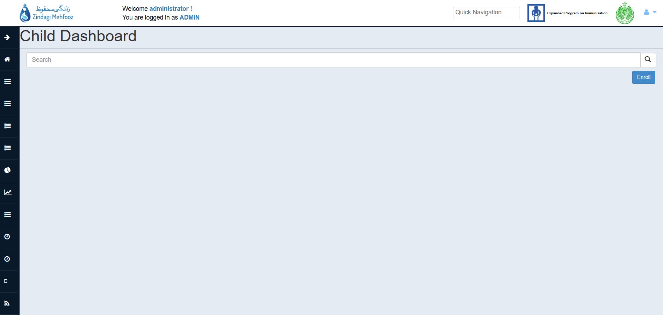

> Child Dashboard is the platform where child level data can be searched or child can be enrolled.

> Enter a QR code to find the child level details belong the ID.

> Child Basic details and Vaccination record along with reminders status can be seen in the report.

6.2. Children Records

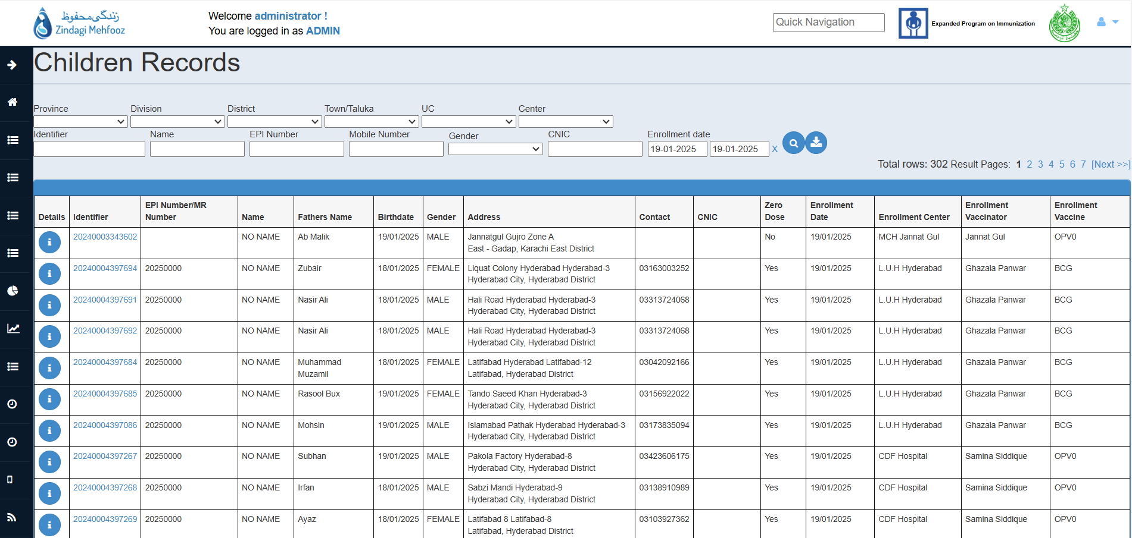

> Children Records shows the number of children enrolled in the area.

> The records are downloadable.

> Data can be filtered through Location and Date filters.

> Click on the Identifier to view child’s EPI card.

6.3. Child/Woman Adverse Event Reports

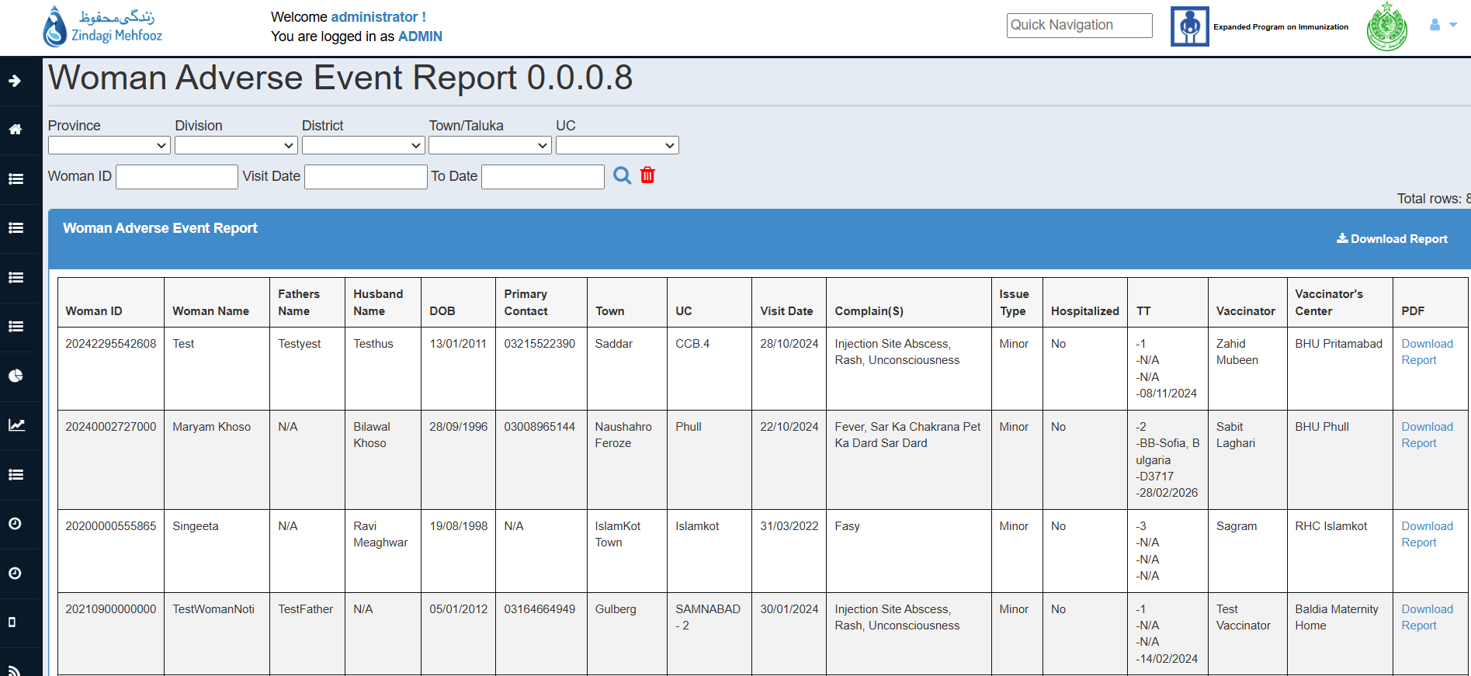
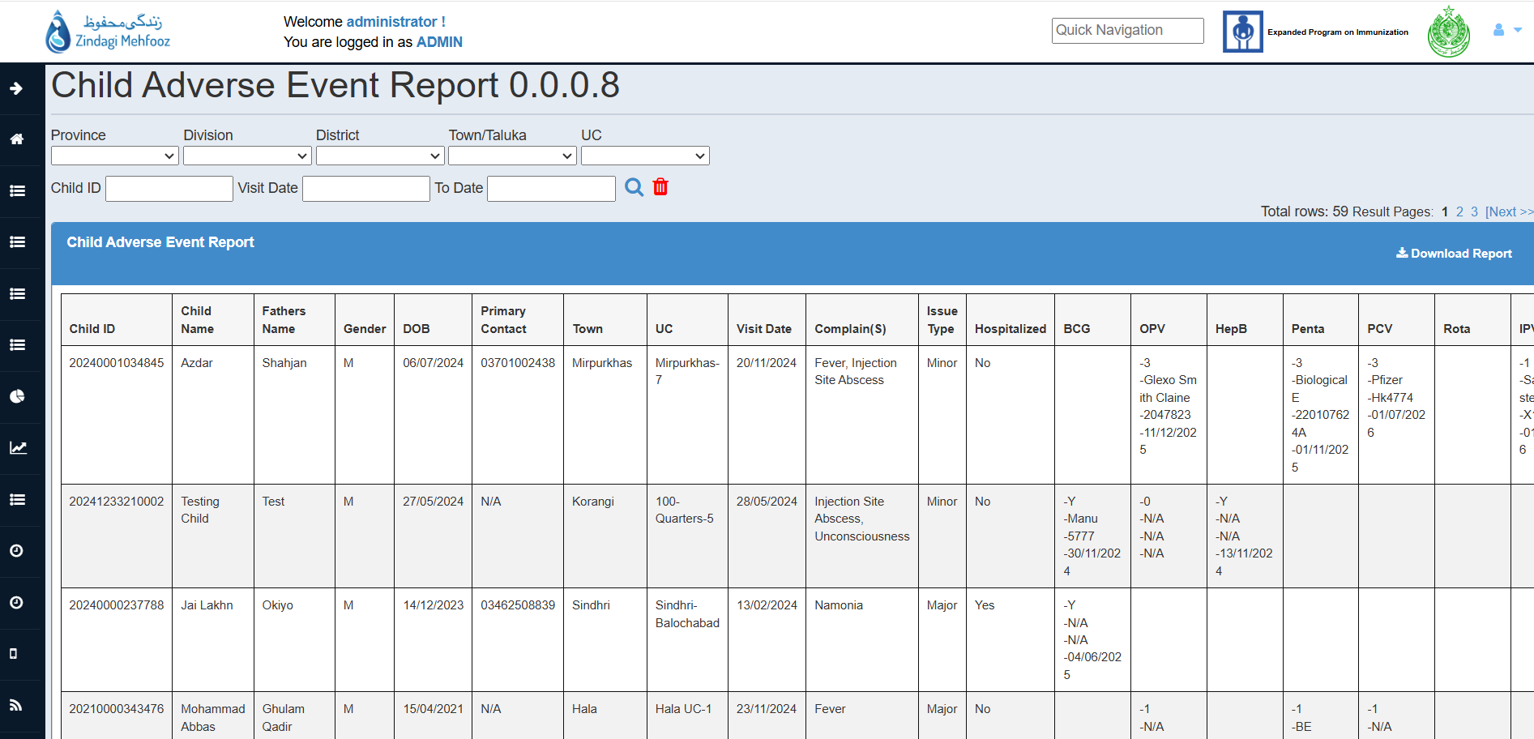

> Adverse Event Report allows to view the event details that are occurred after administration of the antigens, A user can view the complete details of the adverse event including the complains, visit date and reactions as per antigens and it’s details.

> Data can be filtered through Date and Location filters.
> Also individual Adverse and cumulative report of the events can be downloaded from the page in PDF/XLS Formats.

6.4. Zero Dose Registry

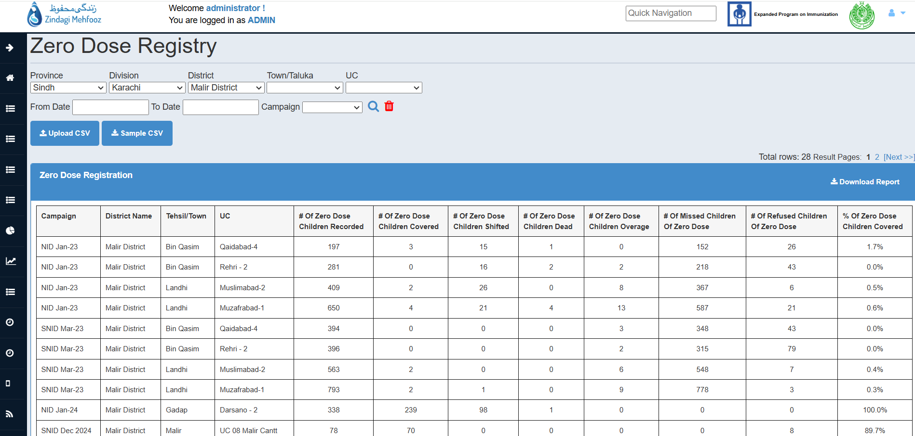
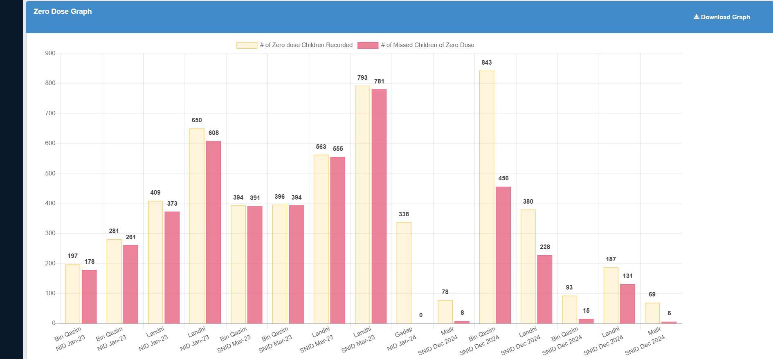

> Zero Dose Regsitry section allows the user to upload and view the statistics of Zero Dose Children being uploaded in the different locations.
> Insights can also be seen through graph which is available on this page.

> Data/Graph can be downloaded in PDF/XLS formats.

> Data can be filtered through Date, Location and Campaign filters.

6.4. Zero Dose Registry (Contd..)

Guide To Upload Zero Dose Children:

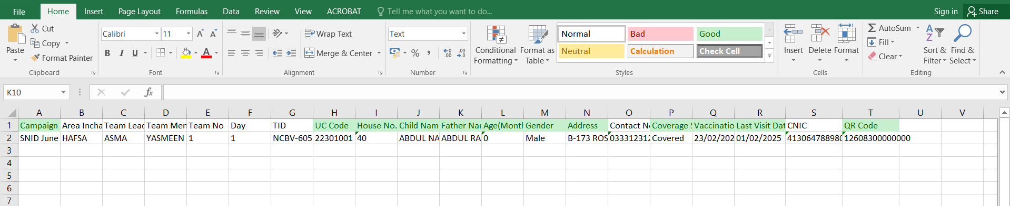

> First, download a format using the Sample CSV button available on the page and then insert zero dose records in that format which you want to upload on the system.

> Note that following instructions must be strictly followed in order to successfully upload sheet on the system.

- Don’t alter the column names/ or remove any column from the sample sheet.

- Some fields are declared as Mandatory which must be filled as per applied validations.

- Campaign, UC Code, House No., Child Name, Father Name, Age(Months), Gender, Address, Coverage Status, Vaccination Date, Last Visit Date, QR Code are Mandatory fields.

- Coverage status include Covered, Refusal, Shifted, Dead, Inaccessible.

- Age should be inserted in Months. For Instance, If a child is 15 days old, then it should be recorded as 0 Months.

- If Coverage status is COVERED then QR Code and Vaccination Date are Mandatory, else QR Code and Vaccination Date are Optional fields.

- Gender must be filled in the format of Male/Female.

6.5. Zero Dose Child Report

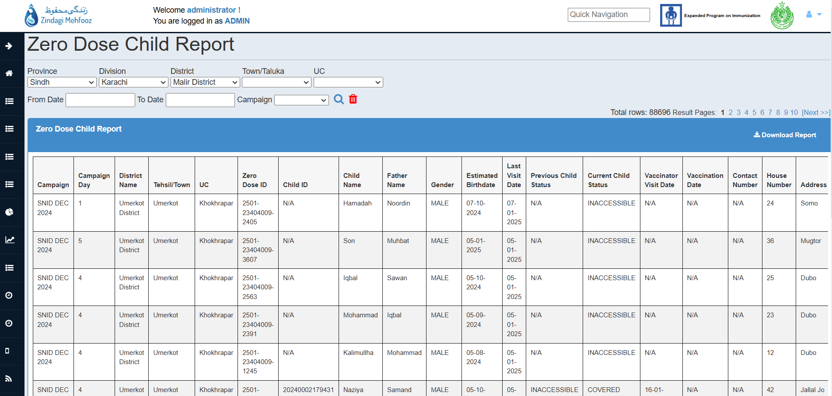

> Zero Dose Child Report allows the user to view the complete details of the records as uploaded from the zero dose registry section.

> Data can be filtered through Location, Date and Campaign filters.

> Report can be downloaded in XLS format by clicking on Download button.

> This is the active report on which you can view the status of the each child record as altered by vaccinator from the ZM Application.

7. Management
Management section allows you view/add/edit the dashboard and application users. It also includes management of the leaves, public holidays, attendances, creation and updation of the health facilities(Vaccination Center) also the real-time tracking of the vaccinators.

7.1. ATS > Monthly Attendance Sheet

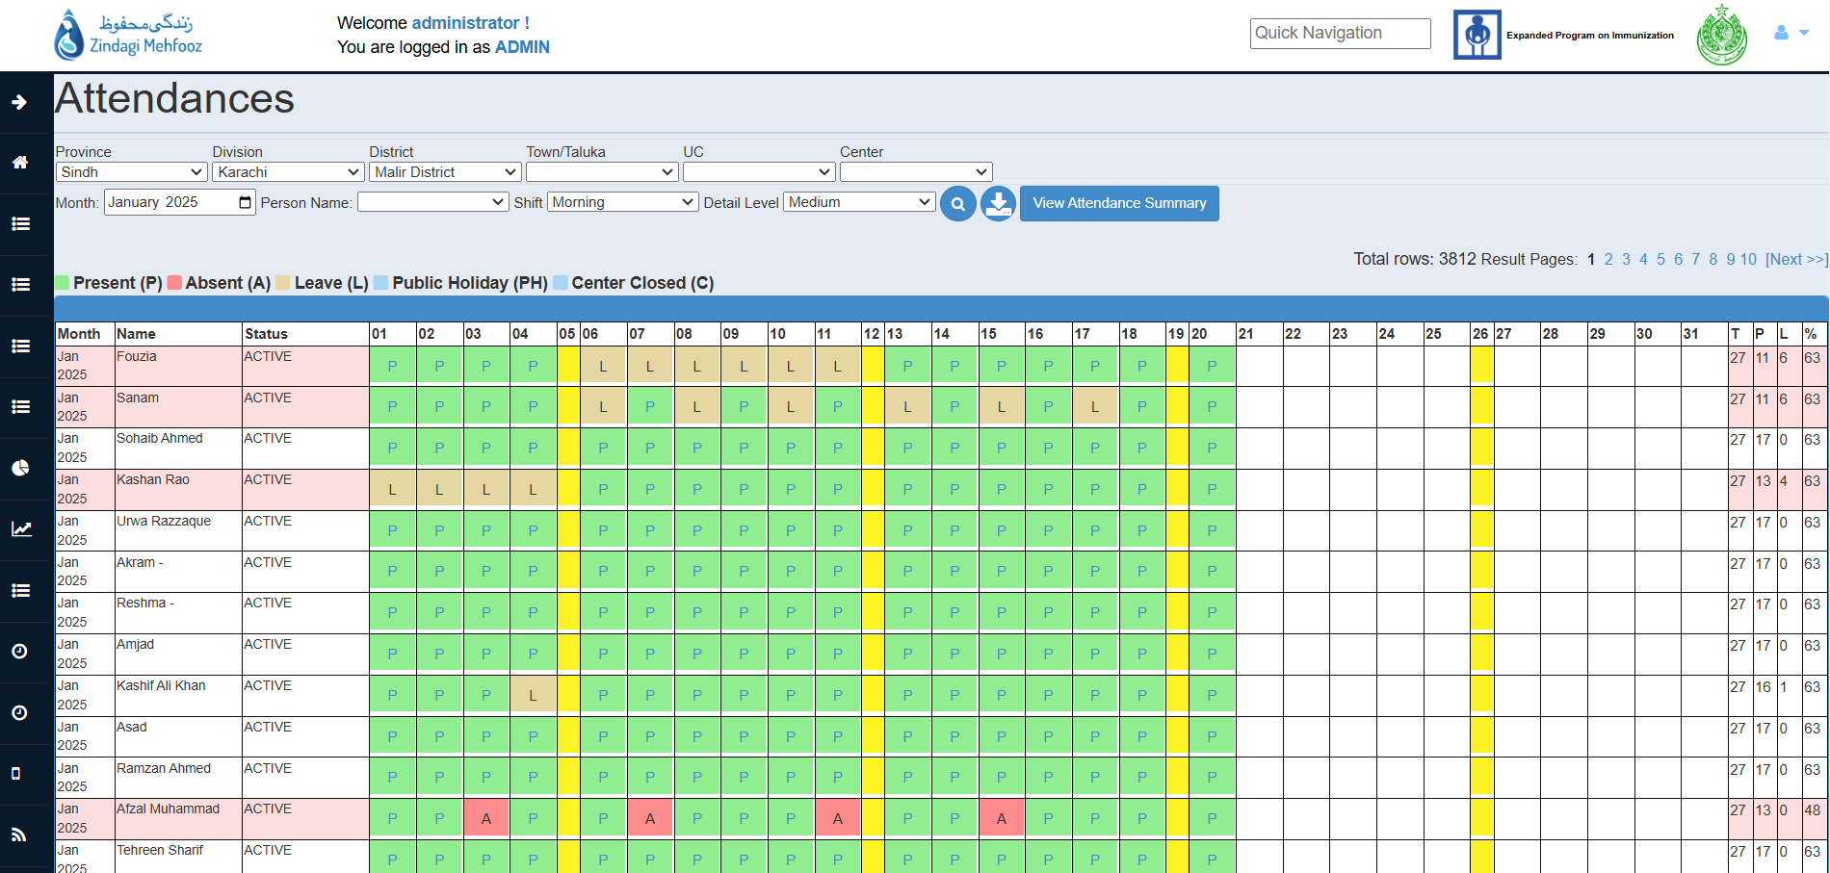

> Attendance sheet shows Number of days Vaccinators are present in line with their leaves and absenteeism.

> The sheet can be seen and downloaded for the given date range and selected area.

> Click on View attendance summary to view the attendance summary (The attendance summary shows percentage % that how many Vaccinator present, absent, leave and unmarked attendance)

> The level of detail can be changed between Low, Medium, High and Time details.

> Also, attendance of shifts(Morning/Evening) can be seen separately by opting the Shift filter.

7.2. ATS > Leave Details

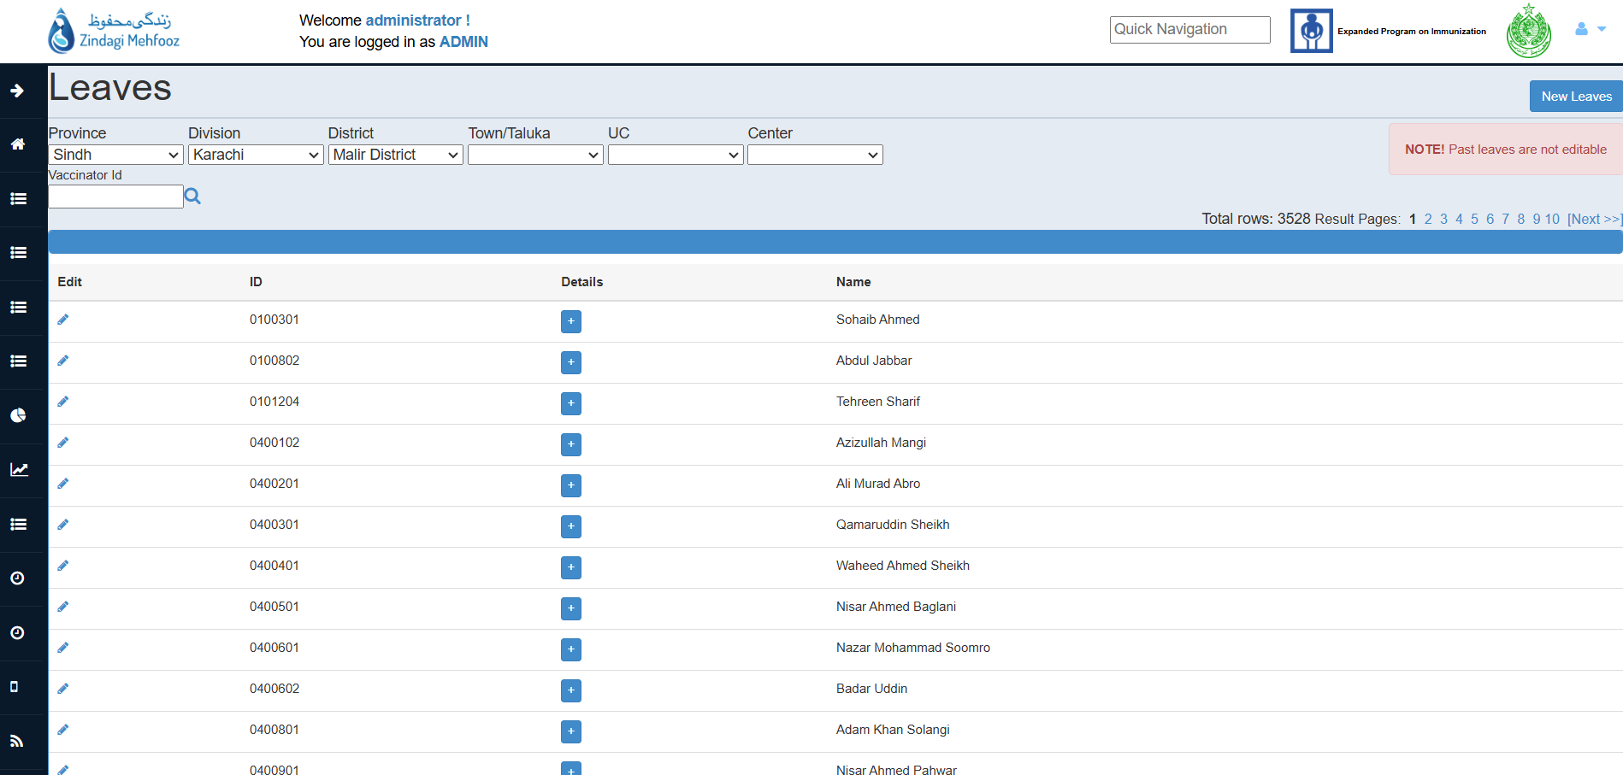

> Previously applied leaves can be viewed and edited by clicking on edit icon (Note that only the POST LEAVES i.e. leaves after the current date are editable)

> Leaves can be filtered through Location and Vaccinator ID.

Guide To Add New Leave(s):

> Click on New Leaves button, Leave form will appear.

> Add Location hierarchy of the vaccinator and select vaccinator from the drop-down.

> Enter other mandatory details like startDate, endDate, leave Reason, select leaveType and Shift.

> Then click on Submit Data button to submit the leave form.

> Leave will now start reflect against the vaccinator in the Monthly Attendance sheet.

7.3. ATS > Public Holiday

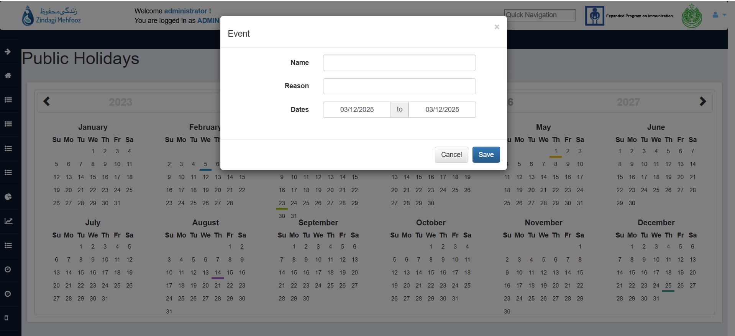

> Following section allows you to mark any holiday in the system, the marked holiday will be reflecting in the Monthly Attendance Sheet.

> When render on this page, already marked holidays for the current year will be reflecting as highlighted with different colors.

Guide To Mark Public Holiday:

> Click on any date on which you want to mark the Public Holiday.

> A Form will appear, enter details of the holiday i.e. Name and Reason.

> Click on Save button to successfully add the Public Holiday.

> After successful completion, Public Holiday will be displayed on the Monthly Attendance Sheet.

Note: Don’t mark range of Public Holidays at once, instead mark Public Holiday for single day separately.

7.4. HR Management > Users > Users

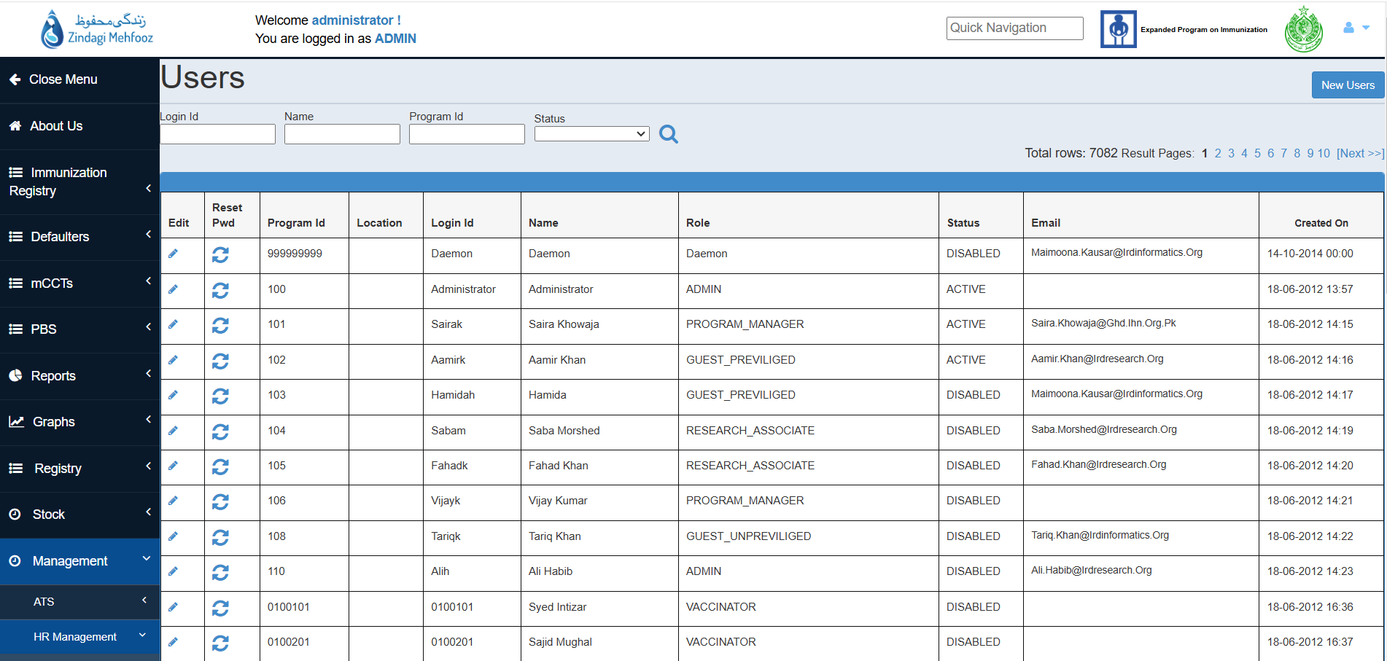

> List of (ACTIVE/DISABLED) users of both mobile and desktop are being reflected on this page, which can be filtered by selecting Status from the drop-down.

> Users can be filtered by their ID’s, name and program Id.

Guide To Reset Password Of User:

> In order to reset the password of the user, Click on RESET icon available against each user.

> System generated password will be reflecting on alert, copy that password and use it for logging into the system.

> Later On, use that system generated password to change the password of the dashboard.

> For changing the password from the dashboard, click on the top right corner of the dashboard and click on Change Password.

Guide To Edit User:

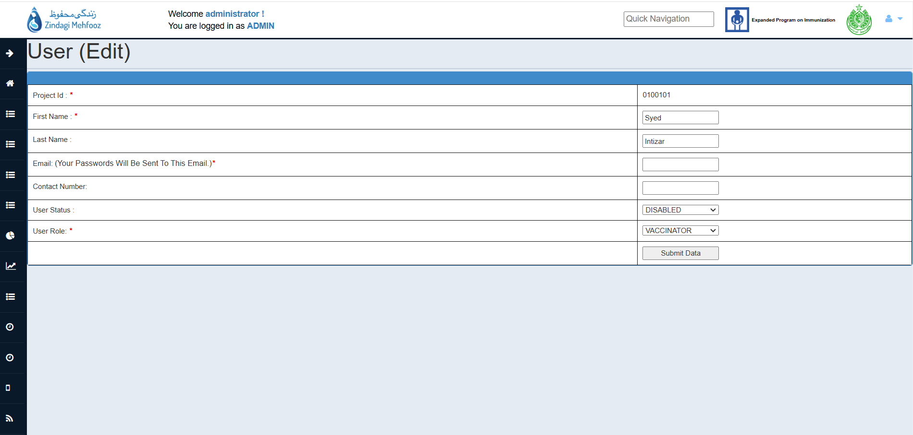

> On Clicking the edit icon, against user. Following screen will appear.

> In order to Disable the user, change the User Status to DISABLED, which is then no longer accessible to mobile/desktop application(Note that you can re-enable the user at any time by following the same process and changing the User Status to ACTIVE)

> First Name, Last Name and User Role can also be updated from the same page, Just alter the details and click on Submit Data button.

Guide To Add New User:

> In order to add new user, click on New User button available on top-right corner of the User’s page.

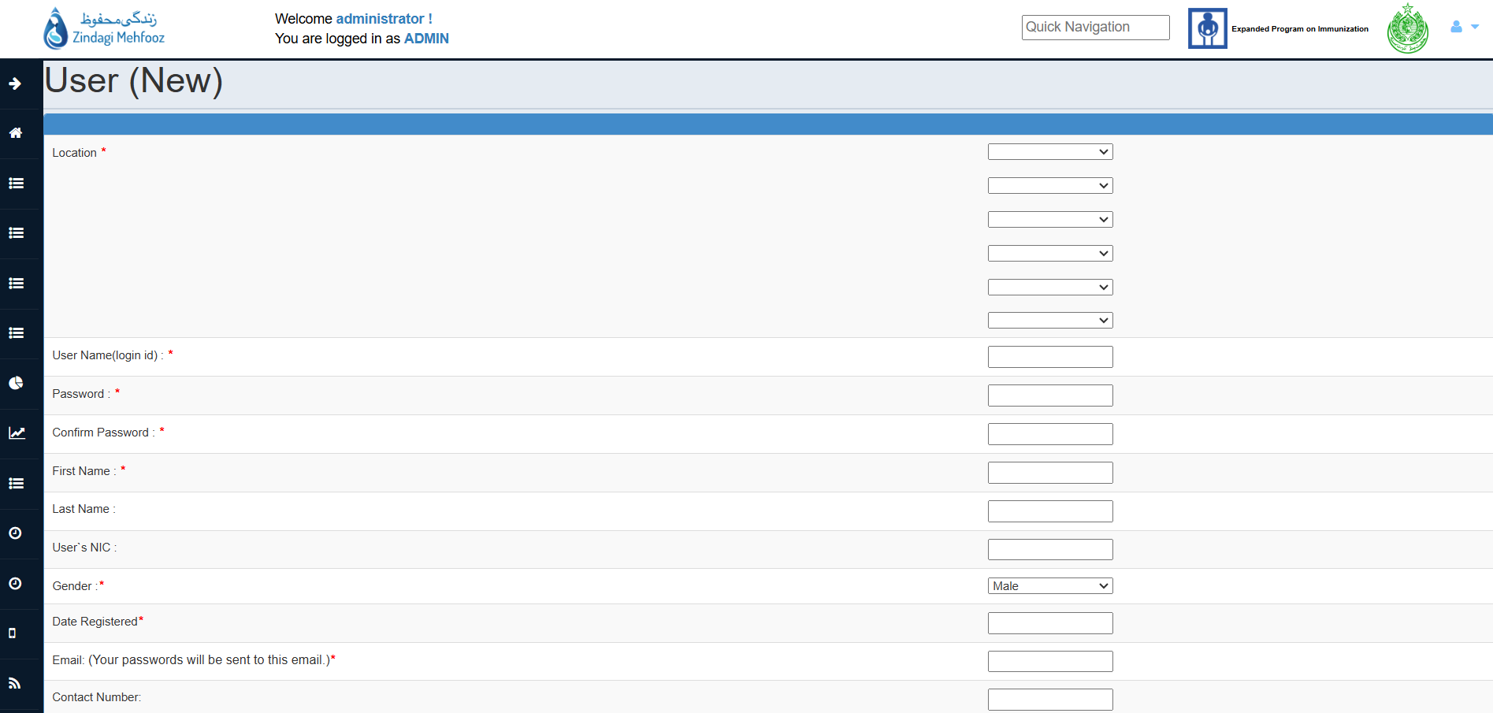
> On clicking that button, the following screen will appear.
> Fill in all the mandatory fields in order to create the user (Mandatory fields are marked with asterisk (*)).

> You may select any location-level while creating user, if no location is selected during creation, the following user will have a access of whole Sindh data.

> After filling necessary details click on Submit Data button, the user will be created successfully.

Note: Don’t create user with any VACCINATOR role from this page as there is a separate page for that category of users.

7.5. HR Management > Users > Roles

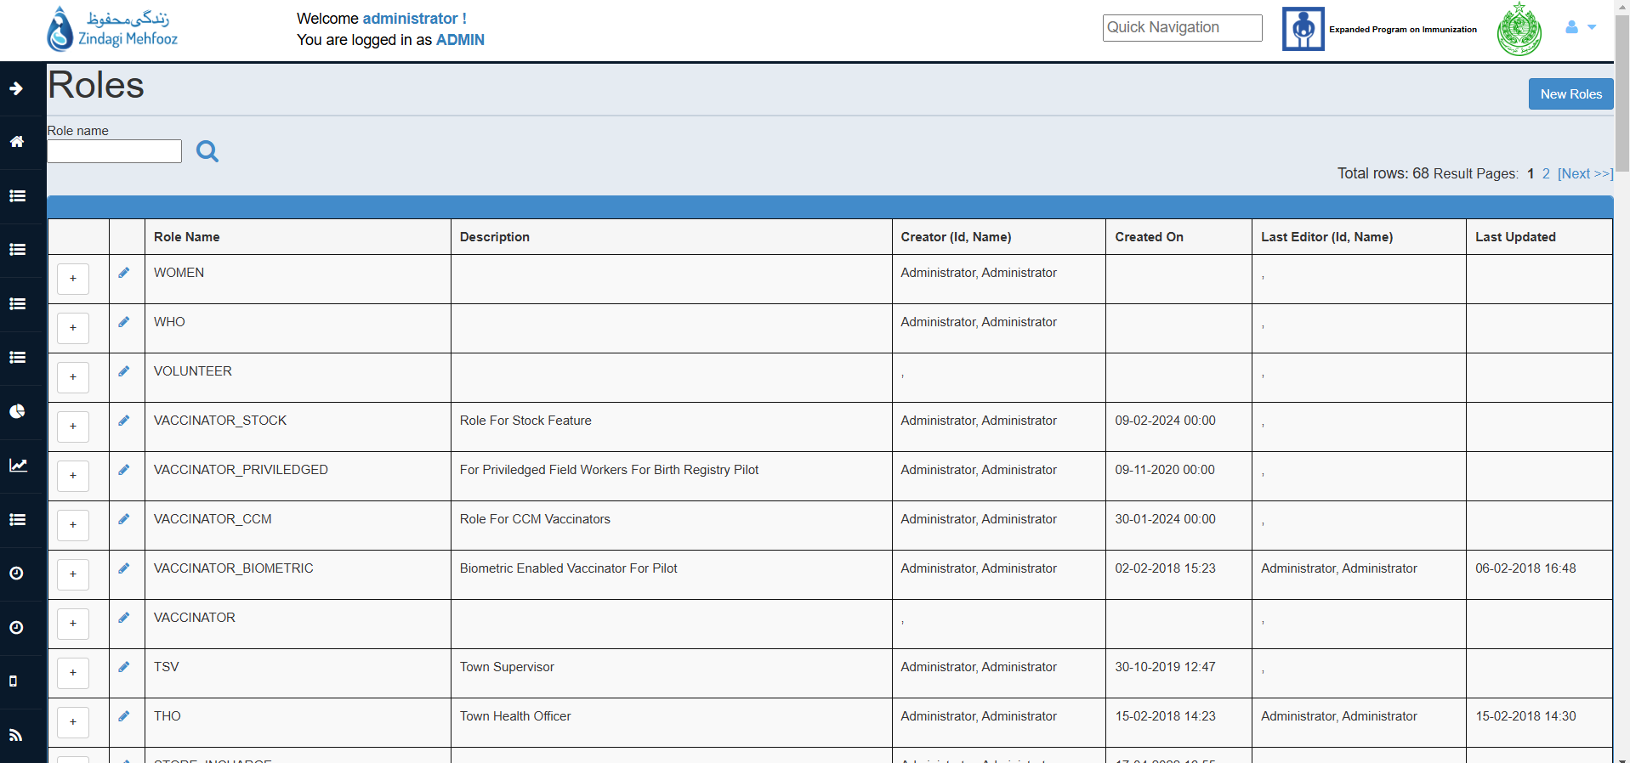

> List of roles available in the system are being reflected on this page.

> In order to view the permission against each role, Click on + icon.

> Roles can be searched by their names, by using Search icon available on the top left corner of the screen.

Guide To Add New Role:

> Click on New Roles button to add new role.

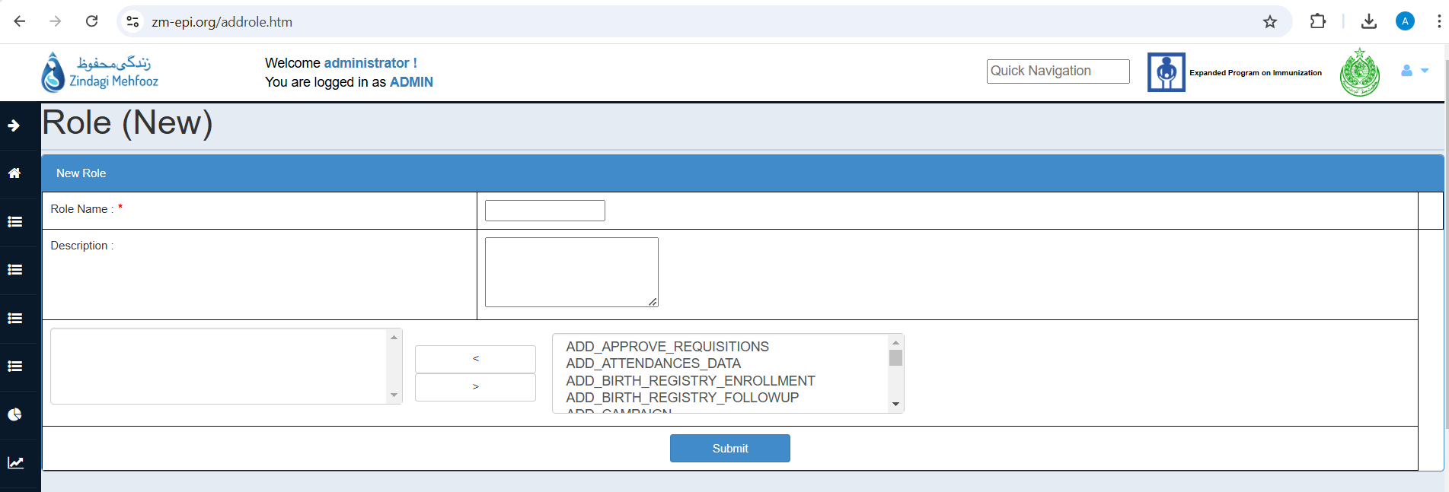

> Following screen will appear, give unique Role Name and description (if required) for the role.

> All Permission are being listed in the table format on the right side, In order to give permission to that role, Single Select OR multi select the permissions and press < button to move these permission to the left table.

> On doing this, permissions will be assigned to that newly creating role.

> Click on Submit button, role will be created successfully with the assigned permissions.

Note: If permissions are mistakenly moved at the left table and you want to remove that permission just select that specific permission and click on > button to move that to the right table.

Guide To Edit Role:

> By clicking on Edit icon available against each role, you can edit the role.

> Role Name and permissions can be updated from this page.

> In order to remove permissions, select that specific permission you want to remove and click on > button to move that to the right table. Selected permission will be removed.

> Click on Submit button to apply the changes.

7.6. HR Management > Vaccinators

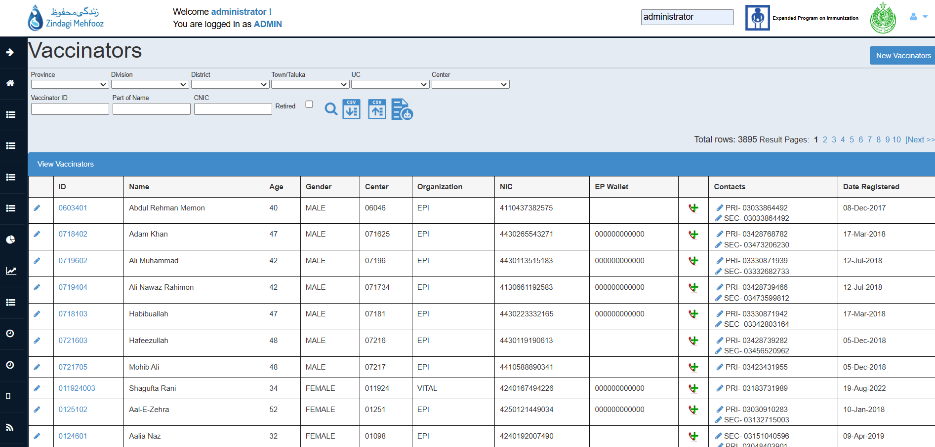

> List of vaccinators of mobile application are being reflected on this page, which can be filtered by checking the Retired checkbox to reflect only RETIRED/VOIDED vaccinators.

> Complete details of the vaccinator can be seen by clicking on the ID of the vaccinator.

> Vaccinators can be filtered by their ID’s, name, CNIC and location filters.

Guide To Add/Edit Contact Number:

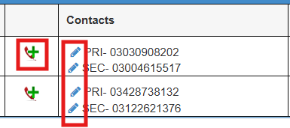

> If forgot to add contact number(s) during vaccinator creation, then it can be added later by clicking on + icon reflecting against each vaccinator.

> In order to edit/update the existing contact either PRIMARY/SECONDARY , click on Edit icon reflecting against contact number.

Guide To Edit Vaccinator Details:

> In order to edit the vaccinator details i.e. name, username, organization, CNIC or any other details, just click on Edit icon available on the left of the each record.

> Amend the details and click on Submit Data to successfully edit the vaccinator.

> Similarly, If you want to void the vaccinator select Retired/Voided option as YES, then select the option of reason of the retirement on the Edit page of the vaccinator and click on Submit Data to successfully void the vaccinator.

Guide To Update Vaccination Center of Vaccinator:

> In order to update the center of the vaccinator, click on Edit icon available on the left of the each record.

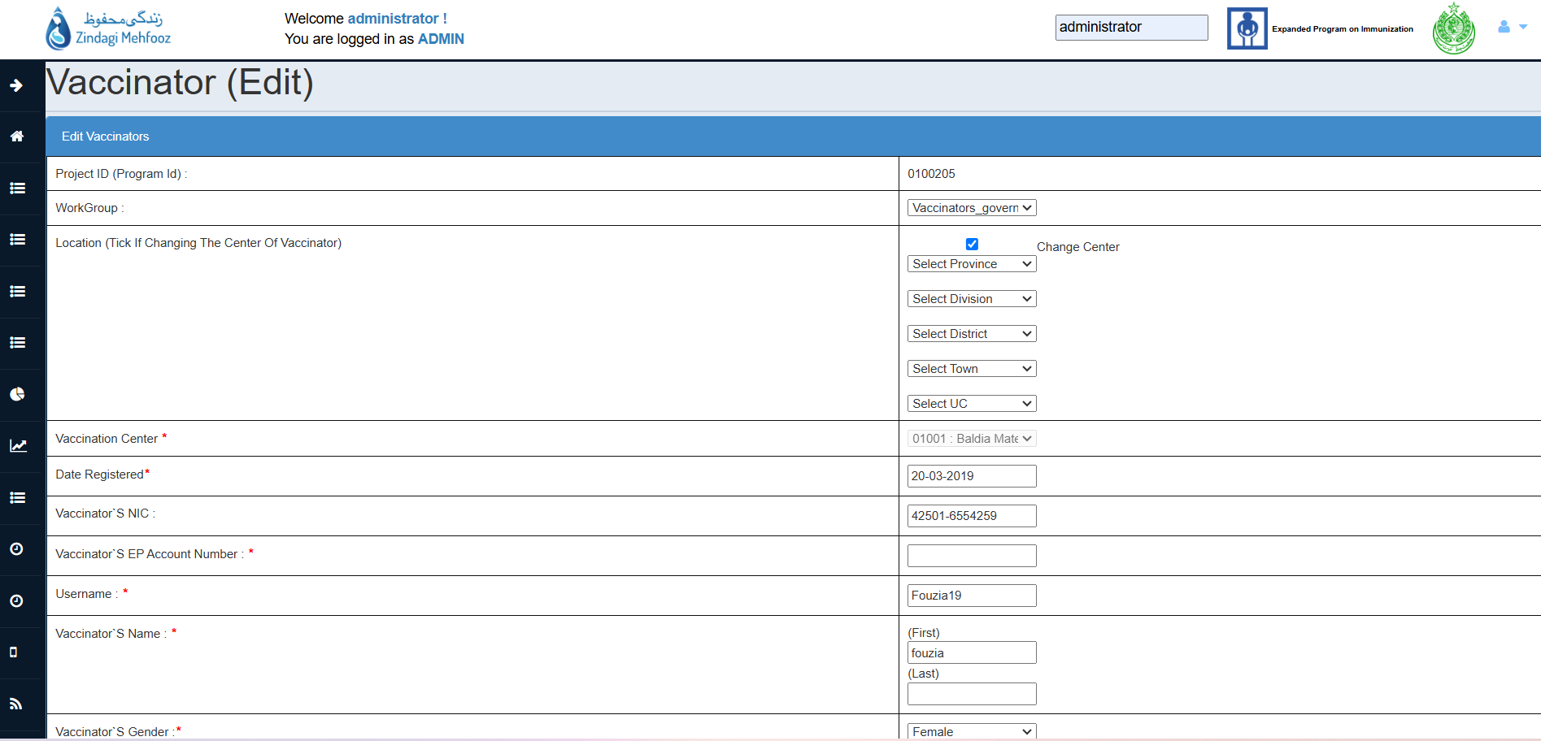

> Upon clicking, the above form will appear, mark the checkbox Change Center.

> Select the location hierarchy and Vaccination Center from the drop-down accordingly where you want to shift the vaccinator.

> Click on Submit Data button to save the changes.

Guide To Add New Vaccinator:

> In order to add new vaccinator, click on New Vaccinator button available on top-right corner of the Vaccinator’s page.

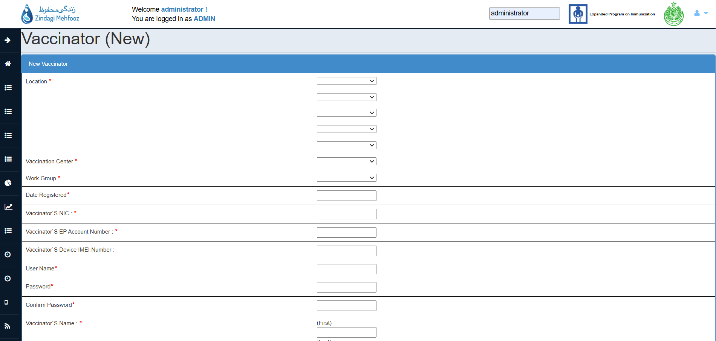

> On clicking that button, the following screen will appear.
> Fill in all the mandatory fields in order to create the vaccinator (Mandatory fields are marked with asterisk (*)).

> Select complete location hierarchy till Vaccination Center while creating vaccinator.

> Assign role: VACCINATOR for creating routine vaccinators and for birth registry vaccinator assign the role: VACCINATOR PREVILIGED

> After filling necessary details click on Submit Data button, the form will be directed to the CONTACT NUMBER screen.

> Select Mobile/Landline as number type and enter contact number (Note that contact number must contain 11 digits if type(mobile) is selected and must start from 03).

>Then click on Submit Data button to successfully add the vaccinator.

7.7. HR Management > Vaccination Center

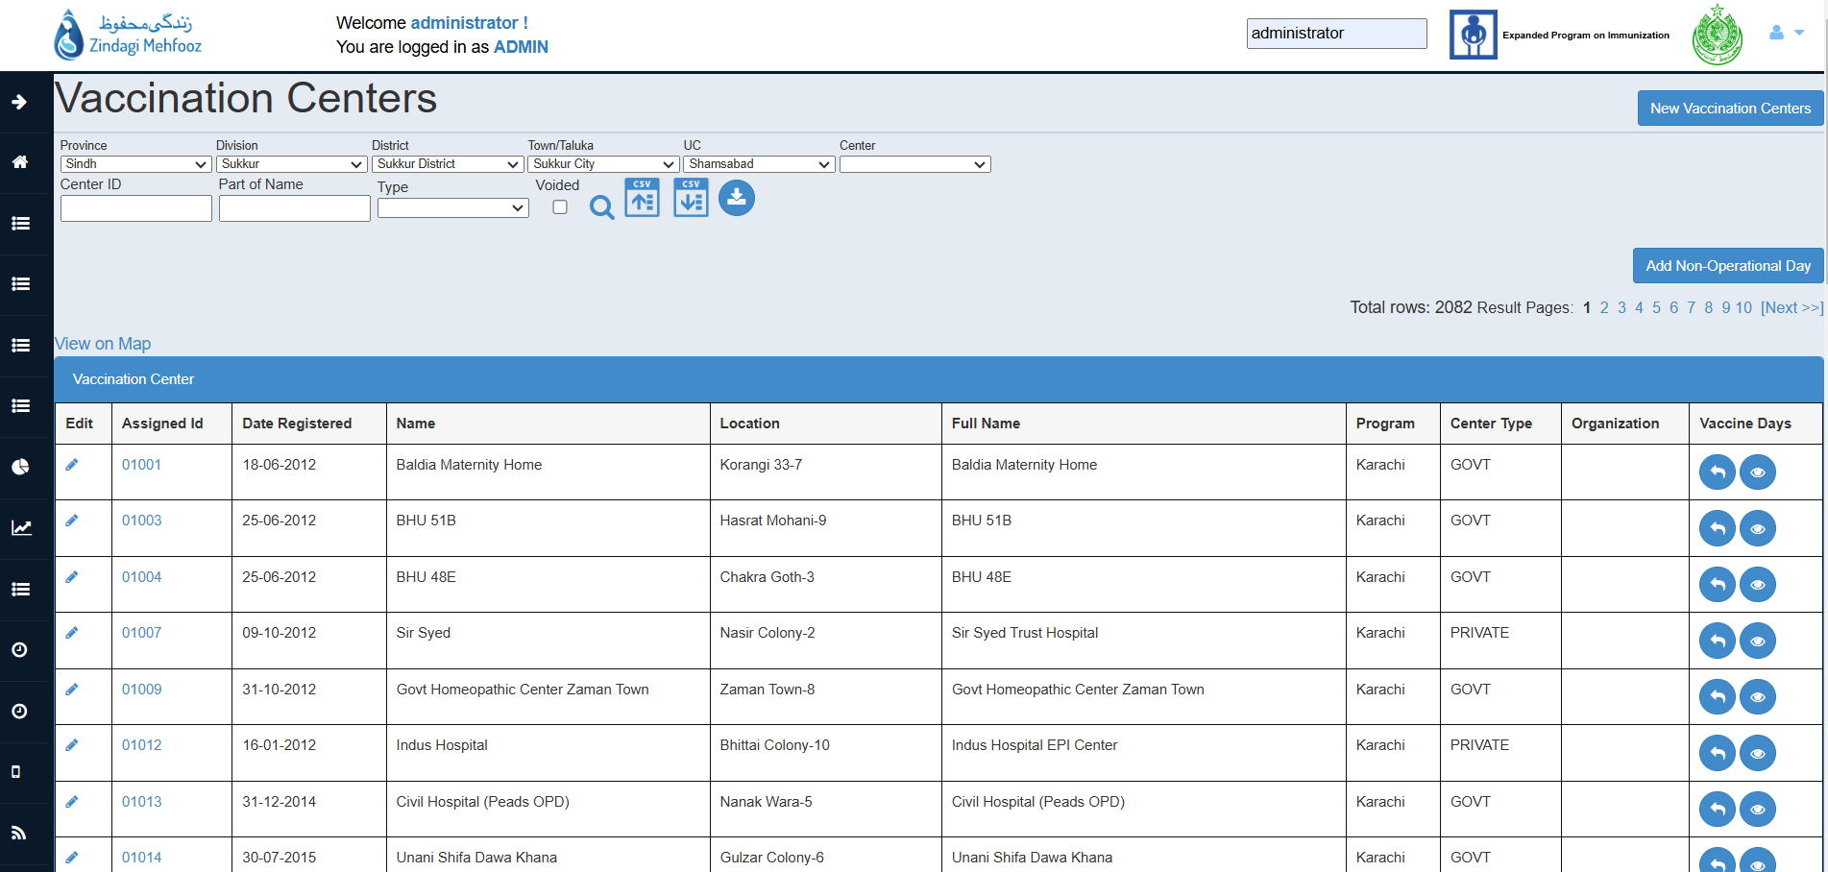

> List of vaccination center(Health Facility) are being reflected on this page, which can be filtered by checking the Voided checkbox to reflect only RETIRED/VOIDED vaccinators.

> Complete details of the vaccination center’s vaccine days can be viewed by clicking on Eye icon available against each vaccination center.

> Centers can be filtered by their ID’s, name, type and location filters.

Guide To Edit/Void Center and Details:

> In order to edit the center details i.e. name, center type,Vaccine days or any other details, just click on Edit icon available on the left of the each record.

> Amend the details and click on Submit Data to successfully edit the center.

> Similarly, If you want to void the center select Voided option as YES, then give the reason of the void on the Edit page of the center and click on Submit Data to successfully void the vaccination center.

Guide To Add New Vaccination Center:

> In order to add new vaccination center, click on New Vaccination Centers button available on top-right corner of the Vaccination Center’s page.

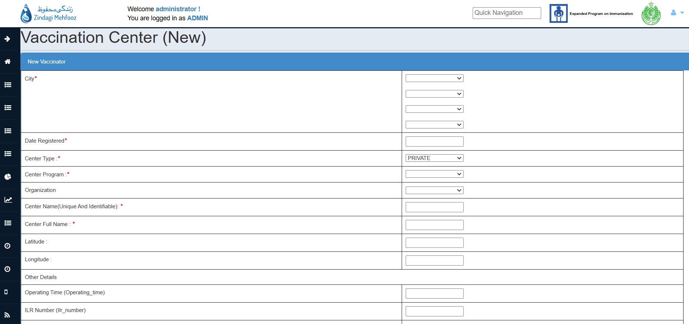

> On clicking that button, the following screen will appear.
> Fill in all the mandatory fields in order to create the vaccination center (Mandatory fields are marked with asterisk (*)).

> Select complete location hierarchy Division till Union Council(UC) while creating vaccination center.

> While entering Center Name, note that it must be unique and there should not exist center with the same name.

> After filling necessary details click on Submit Data button, the center will be created successfully.

Guide To Add Center Close Day:

> In order to add vaccination center non-operational day(close day), click on the Add Non-Operational Day button.

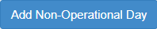

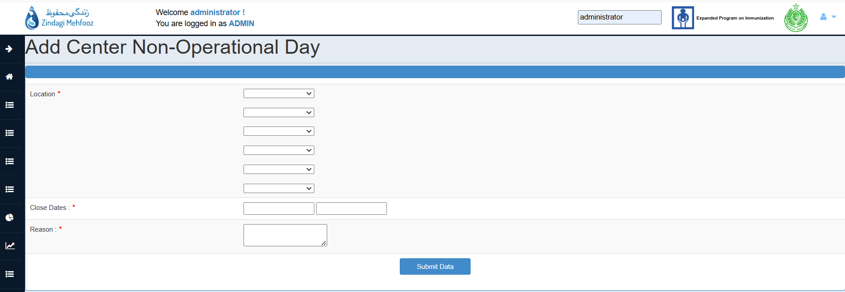

> Upon clicking, the following form will appear.

> Select location hierarchy till vaccination center.

> Select Close dates of the center and provide the reason of closure.

> Click on Submit Data button to successfully add the center closure day.

> Center Closure day(Non Operational Day) will start reflecting in the Monthly Attendance Sheet.

